## MODULE 4 - PERFORM DATA CALCULATIONS

Calculations are a common task for data analysts. In this part of the course, you’ll explore formulas, functions, and pivot tables in spreadsheets and queries in SQL, all of which will help with your calculations. You’ll also learn about the benefits of using SQL to manage temporary tables.

### **Learning Objectives**

* Describe the use of functions to conduct basic calculations on data in spreadsheets
* Discuss the use of pivot tables to conduct calculations on data in spreadsheets
* Demonstrate how to use SQL queries to complete calculations in SQL
* Explain the importance of the data-validation process for ensuring accuracy and consistency in your analysis
* Discuss the use of SQL queries to manage temporary tables
* Reflect on how conditional statements can be used to create complex queries and functions
* Generate multiple points of summary based on a wide variety of conditions using COUNTIF, SUMIF, MAXIF, and AVERAGEIF

## GET STARTED WITH DATA CALCULATIONS

### [DATA CALCULATIONS](https://www.coursera.org/learn/analyze-data/lecture/HZjQ8/data-calculations)

As a data analyst, you'll use key tools and processes over and over, but you'll also learn new things as you grow in your job. It could be anything from building a new kind of analysis to a time-saving shortcut.

When I first got to Google, I relied on just a couple of programs and tools to access data and do my analysis. But I soon realized that I wasn't working as efficiently as I wanted to. Once I got comfortable pulling data and analyzing it using SQL, it allowed me to be a lot more efficient than before. And the better I got at SQL and pulling the data from data tables, the faster I completed my analysis. I was hooked.

Over the next few videos, **I will show you some ways to be as efficient as possible while completing calculations during your analysis**.

We'll start by revisiting spreadsheets where we'll look at **formulas for basic calculations**.

Then we'll move into **conditional formulas that use the IF function** to check whether a condition is met through a calculation.

After that, we'll explore the multifunctional **SUMPRODUCT function**. Try saying that five times quickly! SUMPRODUCT adds and multiplies all in one step, so it's very useful.

Next we'll take another look at **pivot tables**. If you've skipped around, and it's your first time learning about them, you'll get to know all about them. Pivot tables have tons of uses, including organizing your calculations.

We'll then pivot to SQL, pun intended. We'll show how **queries and calculations go hand in hand in SQL.**

We'll also look at **temporary tables in SQL**, which are helpful for temporarily storing your data during analysis.

We'll be covering lots of new concepts in these videos, so feel free to hit the pause button at any time to think through the problem or steps to try it on your own. And you can always review the videos as much as you need to.

So to recap, we'll have a little bit of a review, and then cover some all new concepts, all about calculations. Are you ready? Good. Me, too.

### [COMMON CALCULATION FORMULAS](https://www.coursera.org/learn/analyze-data/lecture/33kSX/common-calculation-formulas)

You probably do a lot of calculations in your daily life. Maybe it's figuring out how much to tip someone or balancing your budget. You might do some of these calculations in your head or with paper and pencil or the calculator on your phone. You might even have shortcuts to use to make the calculations easier. You'll perform a lot of calculations as a data analyst too. But they'll involve more numbers in a wider range of calculations. That's where you'll put your data analyst tools to work. We'll show you how you could use formulas in a spreadsheet to complete some of the most basic calculations. Formulas are one of the many shortcuts that data analysts use. But rest assured, even though they're shortcuts, they'll still calculate with complete accuracy. We've covered a lot of these calculations earlier in the program. But if you skip that part and want a refresher, we'll review them here. These calculations will also be more advanced than the ones we've covered so far. But they'll also be closer to what you might use on the job. We'll be using Google Sheets in this video, but you can also use Excel. The steps might look a little different in Excel, but the outcomes will be the same.

Let's try out some calculations with sales data from a discount store chain. We'll look at data for one of the stores in the chain. Our objective: use the existing sales data to find any trends. This is a great way to see a lot of the ways formulas can be useful in your analysis.

We'll start by finding annual sales over the years 2011-2020. The data is already organized in columns by month and in rows by year. **But we don't have the total sales for each year yet.** We can use a sum function to help us figure that out. We'll add the sales from 2011 first. We'll add a heading for the annual sales column, then we can type our sum function and a formula. All formulas begin with an equal sign. We'll type that first, followed by sum and then an open parenthesis. After the open parenthesis, we need to tell the formula which cells are being added. In this case, we need data from the whole row which begins in cell B2. B2 is a cell reference we'll use. Instead of typing each cell one by one, we can put them in the formula quickly by selecting cell B2 and dragging the fill handle across the row to the last cell with sales data, M2.Now we'll complete the formula by closing the parentheses and pressing Enter.

Just like that, we've calculated the total sales for 2011. Here's another shortcut we worked with in an earlier video. The fill handle is the tiny box in the corner of each sale. You can use it for lots of things like selecting multiple cells for a formula or continuing a pattern across several cells, the fill handle definitely qualifies as a shortcut. We can use the formula we created to calculate the total sales for the other years in the dataset. All we have to do is drag the fill handle down the other cells in the annual sales column and we'll have total sales data for the rest of the years in the dataset.

**Let's say, we also need to find the growth in annual sales from year to year.**

**This would be a good time to think through the problem before we try to solve it**. Do we have the data we need to solve this? Not yet. Thinking backwards like this helps us plan out the steps to move forward.

The first step we'll need to do is calculate the total sales per year. Then we'll measure the rate of change between years. We'll start by labeling a new column.

In this case, we won't need to use a function or parentheses, since we're only using data from two cells. We can just use the name of those cells, we'll type an equals sign and then click in "Cell N3", which automatically populates that sale in the formula. Next, we'll add a minus sign to the formula because we're subtracting to find the difference between two consecutive years. Clicking in "Cell N2" gives us the total from 2011, which we can then subtract from the total from 2012. Then we hit Enter and get our sales growth from 2011-2012. We're definitely getting some useful data here. Let's keep going. We can also use our sales growth to find the growth rate between the two years. We'll show this as a percentage. We'll head our column with the percent sign and growth. To do this, we'll divide the total in cell O3 by the annual sales from 2011 in cell N2. A slash is a symbol that a formula recognizes as division, so we'll place that between the two cell references and presto, there's the growth rate. Growth rates are usually shown as percentages, which can be easier than a decimal to read and understand. Let's change this number to a percentage. Time for another shortcut. All we have to do is click the percent style button and our growth rate will become a percentage. We can select the cells for both the total growth and the growth rate to populate the rest of the two columns.

We have some negative numbers, but that just means that there was negative growth from one year to the next. We've got just a few more things to calculate for our stakeholders. Next step is finding the average sales. We want to compare sales between months to learn if there's a trend. We'll add this in a row instead of a column. This will line up our averages under each month.

To find our averages, we’ll calculate the total and then divide that total by the number of values added to get it. We can do this by using the average function.

Between our parentheses will select the cells that contain the sales data for January, B2 through B11.

We'll duplicate that formula across the row through December to look for trends.

Right away, we know that summer months and December have the highest average sales.

Since our stakeholders will want to understand our findings quickly and easily, we'll add a little visualization to the data with conditional formatting. You'll learn more about data visualizations like conditional formatting soon. But here's a sneak peek. Conditional Formatting is a spreadsheet tool that changes how cells appear when values meet specific conditions. Let's apply conditional formatting to the cells with the average sales by month.

We'll use a color scale to show the range of averages. Well, the lowest monthly average remaining as white and we'll apply shades of green to the rest of the values.

The brighter the green, the higher the average. Now, when we share our analysis with our stakeholders, they will be able to tell right away which months have the highest average sales. Just a couple more steps to complete our analysis. Now we need to find the minimum and maximum for average monthly sales. With the dataset this small, it might be easy to find the minimum and maximum values without a formula, but it's still good practice to use one. Not to mention, using a formula helps prevent human error, will again rely on formulas with Functions to do these calculations, we'll start with the lowest monthly average.

Our function here is MIN, followed by the cells with the average month B12 through M12.

After we press Enter, the lowest monthly average is calculated. We can repeat the same steps to find the highest monthly average,

in this formula will use the same data, but we'll replace MIN with MAX for maximum.

For this store location, sales are strongest in December and weakest in January. We could share these findings with stakeholders if they've met our objectives. If they haven't, we might need to continue with our analysis. Either way, I hope you've learned how spreadsheet formulas can be valuable tools when doing calculations. Coming up, we'll check out more formulas. See you soon.

### [FUNCTIONS AND CONDITIONS](https://www.coursera.org/learn/analyze-data/lecture/3OFTV/functions-and-conditions)

One of the first calculations most kids learn how to do is counting. Soon after, they learn addition, and that doesn't go away. No matter what age we are, we're always counting or adding something, whether it's change at the grocery store or measurements in a recipe. Data analysts do a lot of counting and adding too. And with the amount of data you'll come across as a data analyst, you'll be grateful to have functions that can do the counting and adding for you.

So let's learn how these functions COUNTIF and SUMIF can help you do calculations for your analysis more easily and accurately. We'll start with the COUNTIF function.

You might remember COUNTIF from some of the earlier videos about data cleaning. **COUNTIF returns the number of cells that match a specified value. Earlier, we showed how COUNTIF can be used to find and count errors in a data set.**

Here we'll only be counting. Just a reminder though, while we won't be actively searching for errors in this video, you'll still want to watch out for any data that doesn't look right when doing your own analysis.

**As a data analyst, you'll look for and fix errors every step of the way.**

For this example, we'll look at a sample of data from an online kitchen supplies retailer.

Our stakeholders have asked us to answer a few questions about the data to understand more about customer transactions, including the revenue they're bringing in. We've added the questions we need to answer to the spreadsheet.

We'll set up a simple summary table, which is a table used to summarize statistical information about data. We'll use the questions to create the attributes for our table columns: count, revenue total, and average revenue per transaction.

Each of our questions ask about transactions with one item or transactions with more than one item, so those will be the observations for our rows.

We'll make Quantity the heading for our observations.

We'll also add borders to make the summary table nice and clear.

The first question asks, How many transactions include exactly one item? To answer this, we'll add a formula using the COUNTIF function in cell G11.

We'll begin with an equal sign, COUNTIF, and an open parenthesis.

Column B has data about quantity. So we'll select cells B3 through B50, followed by a comma.

Next, we need to tell the formula the value that we're looking for in the cells we've selected. We want to tell the data to count the number of transactions if they equal 1. In this case, between quotation marks, we'll type an equal sign and the number 1 because that's the exact value we need to count. When we add a closed parenthesis and press enter, we get the total count for transactions with only one item, which is 25.

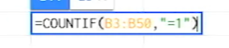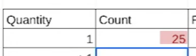

We can follow the same steps to count values greater than one.

But this time, because we only want values greater than 1, we'll type a greater than sign in our formula inside of an equals sign.

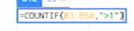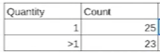

Getting this information helps us compare the data about quantity.

Okay, now we need to find out how much total revenue each transaction type brought in. Since the data isn't organized by quantity, we'll use the SUMIF function to help us add the revenue for transactions with one item and with one more item separately.

**SUMIF is a function that adds numeric data based on one condition.**

Building a formula with SUMIF is a bit different than one with COUNTIF. They both start the same way with an equal sign and the function, but a SUMIF formula contains the range of cells to be evaluated by your criteria, and the criteria. In other words, SUMIF has a list of cells to check based on the criteria you set in the formula. Then the range where we want to add the numbers is placed in the formula if that range is different from the range being evaluated.



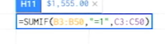

There's commas between each of these parts. Adding a space after each comma is optional. So let's try this. In cell H11, we'll type our formula. The range to be evaluated is in column B, so we'll select those cells.

The condition we want the data to meet is for the values in the column to be equal to one. So we'll type a comma and then inside quotes an equal sign and the number one.

Then we'll select the range to be added based on whether the data from our first range is equal to one. This range is in column C, which lists the revenue for each transaction.

So every amount of revenue earned from a transaction with only one item will be added together. And there's our total. Since this is revenue, we'll change the format of the number to currency, so it shows up as dollars and cents.

So the transactions with exactly one item earned $1,555.00 in revenue. Let's see how much the transactions with more than one item earned.

Okay, let's check out the results. Just like with our COUNTIF examples, the second SUMIF formula will be the same as the first, except for the condition, which will make it greater than one.

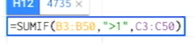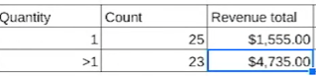

When we run the formula, we discover that the revenue total is much higher, $4,735.00. This makes sense, since the revenue is coming from transactions with more than one item. Good news.

To complete our objective, we'll do two more quick calculations.

First, we'll find the average revenue per transaction by dividing each total by its count. This will show our stakeholders how much of a difference there is in revenue per transaction between one item and multiple item transactions. This information could be useful for lots of reasons. For example, figuring out whether to add a discount on purchases with more than one item to encourage customers to buy more. We'll put these calculations in the last column of our summary table. You might remember that we use a slash in a formula as the operator for division calculations.

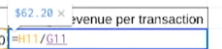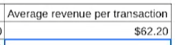

The average revenue for transactions with one item is $62.20.

And the average revenue for transactions with more than one item is $205.87.

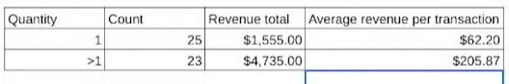

And that's it for our analysis. Our summary table now gives the stakeholders and team members a snapshot of the analysis that's easy to understand. Our COUNTIF and SUMIF functions played a big role here. Using these functions to complete calculations, especially in large datasets, can help speed up your analysis. They can also make counting and adding a little more interesting. Nothing wrong with that. And coming up, we'll explore more functions to make your calculations run smoothly. Bye for now.

### [FUNCTIONS WITH MULTIPLE CONDITIONS](https://www.coursera.org/learn/analyze-data/supplement/s9khi/functions-with-multiple-conditions)

As you’ve been learning, conditional functions and formulas perform calculations according to specific conditions. In addition, functions including **SUMIF** and **COUNTIF** only work in cases where there is one condition.

However, if you have more than one condition, you would need to use the **SUMIFS** or the **COUNTIFS** function instead. These functions enable you to perform calculations if you have two or more conditions. In this reading, you will learn more about conditional functions and how to construct functions with multiple conditions by exploring their basic syntax and checking out an example.

You will also be able to access resources for similar functions in Excel.

## **SUMIF to SUMIFS**

Previously, you learned that the **SUMIF function adds values in a particular range based on a single condition.**

**The basic syntax is =SUMIF(range, criterion, sum_range).**

The first range is where the function will search for the condition that you have set. The criterion is the condition you are applying and the sum_range is the range of cells that will be included in the calculation.

For example, in an accounting spreadsheet, you could use **SUMIF** to calculate the total expenses for a specific category, like Travel expenses, within a given month.

Or, you could find the total sales for automotive fuel treatment products– in this table, the ProductA is high octane fuel and ProductB is standard octane. Table 1 includes columns for Product, Region, Quarter, and Sales.

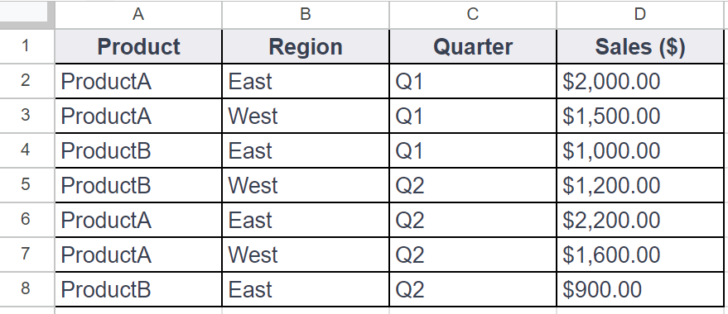

You could use **SUMIF** to calculate the total sales for Product A using a formula like this:

**=SUMIF(A2:A8, "ProductA", D2:D8)**

But, you could also build in multiple conditions by using the **SUMIFS** function. **SUMIF** and **SUMIFS** are very similar: They add up values in a range.

**But SUMIFS can include multiple condition**s. This gives you more control over your summing criteria, which, in turn, allows you to perform more complex data analysis easily.

**The basic syntax is: =SUMIFS(sum_range, criteria_range1, criterion1, [criteria_range2, criterion2, ...])**

The square brackets let you know that this is optional.

The ellipsis at the end of the statement enables as many repetitions of these parameters as needed.

For example, if you wanted to calculate the sum of sales for ProductA in the East district in the first quarter, you could create a **SUMIFS** statement with multiple conditions, like this:

**=SUMIFS(D2:D8, A2:A8, "ProductA", B2:B8, "East", C2:C8, "Q1")**

In this example, B2:B8 is the second criterion_range and East is the second condition. The third criterion_range is C2:C8 and the third condition is Q1.

**As long as you follow the basic syntax, you can add up to 127 conditions to a SUMIFS statement!**

## **COUNTIF to COUNTIFS**

Just like the **SUMIFS** function, **COUNTIFS** allows you to create a **COUNTIF** function with multiple conditions.

The definitionfor **COUNTIF is a function that counts the number of cells in a range that meet a single condition**.

For example, using **COUNTIF** to track the number of days a temporary employee was absent in an attendance record.

**The basic syntax is: =COUNTIF(range, criterion)**

Just like **SUMIF**, you set the range and then the condition that needs to be met. For example, in Table 1, if you wanted to count the number of transactions for ProductA, you could use a **COUNTIF** function like this:

**=COUNTIF(A2:A8, "ProductA")**

**COUNTIFS has the same basic syntax as SUMIFS: =COUNTIFS(criteria_range1, criterion1, [criteria_range2, criterion2, ...])**

The criteria_range and criterion are in the same order, and you can add more conditions to the end of the function. So, if you wanted to find the number of sales transactions for ProductA in the East region in the first quarter, you could use **COUNTIFS** to apply those conditions, like this:

**=COUNTIFS(A2:A8, "ProductA", B2:B8, "East", C2:C8, "Q2")**

This enables you to find every instance where both of conditions (East and Q1) are true.

## **For more information**

**SUMIFS** and **COUNTIFS** are just two examples of functions with multiple conditions. They help demonstrate how multiple conditions can be built into the basic syntax of a function. There are other functions with multiple conditions that you can use in your data analysis and many resources available online to help you get started:

* [**How to use the Excel IFS function**](https://exceljet.net/excel-functions/excel-ifs-function): This includes an explanation and example of the **IFS** function in Excel. It’s a great reference if you’re interested in learning more about **IFS**. The example is a useful way to understand this function and how it can be used.
* [**VLOOKUP in Excel with multiple criteria**](https://exceljet.net/formula/vlookup-with-multiple-criteria): Similar to the previous resource, this resource goes into more detail about how to use **VLOOKUP** with multiple criteria. Being able to apply **VLOOKUP** with multiple criteria will be a useful skill, so check out this resource for more guidance on how you can start using it on your own spreadsheet data.
* [**INDEX and MATCH in Excel with multiple criteria**](https://www.coursera.org/learn/analyze-data/supplement/s9khi/functions-with-multiple-conditions): This resource explains how to use the **INDEX** and **MATCH** functions with multiple criteria. It also includes an example, which demonstrates how these functions work with multiple criteria and actual data.
* [**Using IF with AND, OR, and NOT functions in Excel**](https://support.microsoft.com/en-us/office/using-if-with-and-or-and-not-functions-d895f58c-b36c-419e-b1f2-5c193a236d97): This resource combines IF with AND, OR, and NOT functions to create more complex functions. By combining these functions, you can perform your tasks more efficiently and cover more criteria at once.

### [HANDS-ON ACTIVITY: WORK WITH CONDITIONS](https://www.coursera.org/learn/analyze-data/quiz/abUf7/hands-on-activity-work-with-conditions)



## **Activity Overview**



In previous activities, you used basic spreadsheet functions such as **COUNT**, **SUM**, **AVERAGE**, and **MAX**. In this activity, you will work with the conditional versions of these functions: **COUNTIF**, **SUMIF**, **AVERAGEIF**, and **MAXIFS**.

Conditional functions are functions that perform a specific task, but only on cells that satisfy some defined criteria. They are usually identified with an **IF** suffix adjoined to the desired operation. They are frequently used when constructing more complex queries that cannot be accomplished using more basic functions.

By the time you complete this activity, you will be able to use conditional functions and understand when and why they are appropriate. This will enable you to do more complex analysis with spreadsheets as you continue to develop your data analyst skill set.

### 

### **Step-By-Step Instructions**

### **Step 1: Access the template**

To get started, you will need to access the Working with Conditions spreadsheet.

Click the link to the spreadsheet to create a copy. If you don’t have a Google account, you may download the spreadsheet directly from the attachments below. Make sure to select “Use Template” on the downloadable item.

Link to spreadsheet: [Working with Conditions](https://docs.google.com/spreadsheets/d/1sKNqBzV63Na76jjoKLukjTtDyDMwVW0Vjz4mM-sJDEM/template/preview#gid=895883562)OR[Working with Conditions](https://d3c33hcgiwev3.cloudfront.net/qLRKJmPJTR6yRiMQRNIcfg_918c1ebc887045bba3c61fcdfdc080e1_Working-with-Conditions.xlsx?Expires=1713052800&Signature=g0KaoAE7k-fyyHkwXdcUI5ayTMQNNJWtFixdK24eCTk-62-q~KZr8Znl6U3mN-CEs0OyWXxG1aHuwH8qGPNidkrbMNQjg2WxrMAJITbPOp6F62qwhUikmipeyqh3sgq-qs6ljfHsgCVK6Mu8BAwPRUVlkvpi3NoMsXud05EFY2Y_&Key-Pair-Id=APKAJLTNE6QMUY6HBC5A)

### 

### **Step 2: Use the COUNTIF function**

First, open the Working with Conditions spreadsheet.

In this scenario, your stakeholders have asked you to calculate the number of salespeople that the company has in New York state. The **COUNTIF** function allows you to do this easily. **COUNTIF** counts and returns the number of records in a table that meet a certain criteria—in this case, the number of salespeople a company has in the state of New York. The syntax is **=COUNTIF(**range, criteria).

The range is the array (or collection) of cells that you are checking and the criteria is what you are checking for. All cells in the array that match the provided criteria will be counted and this number returned as the value of the function.

To use this function to count the number of salespeople working from “NY,” click on an open cell. In the function bar, enter **=COUNTIF(B2:B21, "NY")**.

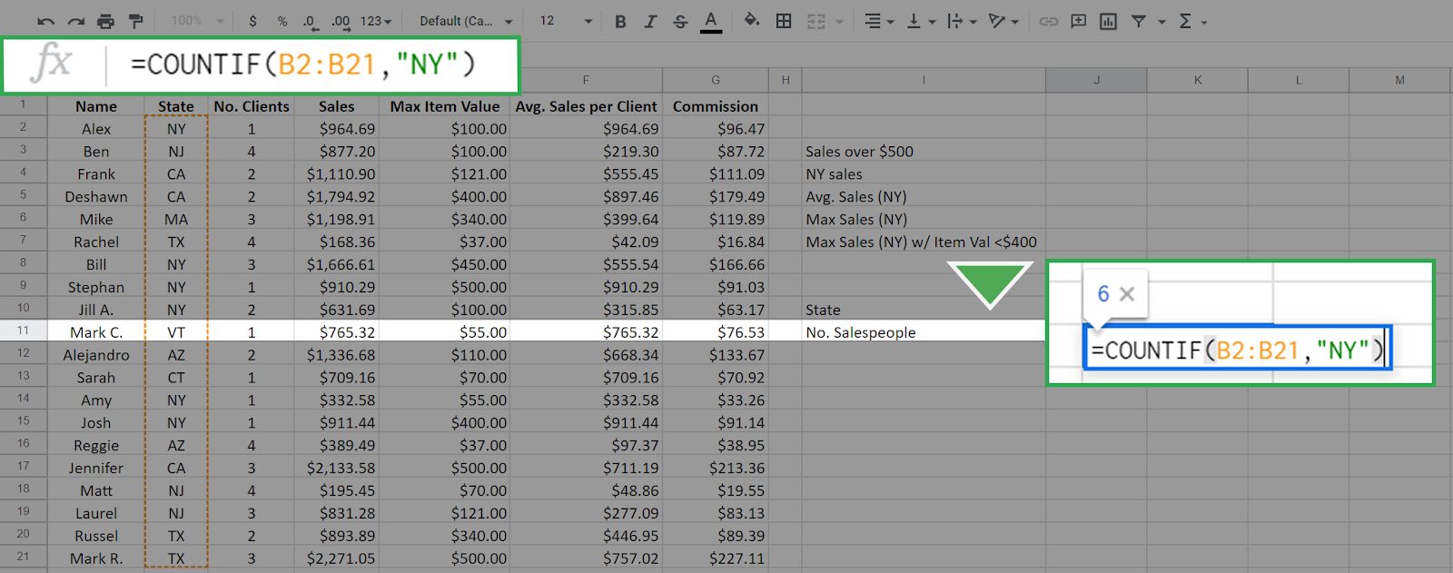

The range is the array of cells from B2 to B21. This is all from column B with the exception of the column header. The function checks all cells in this array against the value “NY” (entered in quotes) which is the criteria. Every cell in this array with a value of “NY” will be counted, and the result is returned in the cell. It is 6 in this case.

Press Enter/Return. The result should display like this:

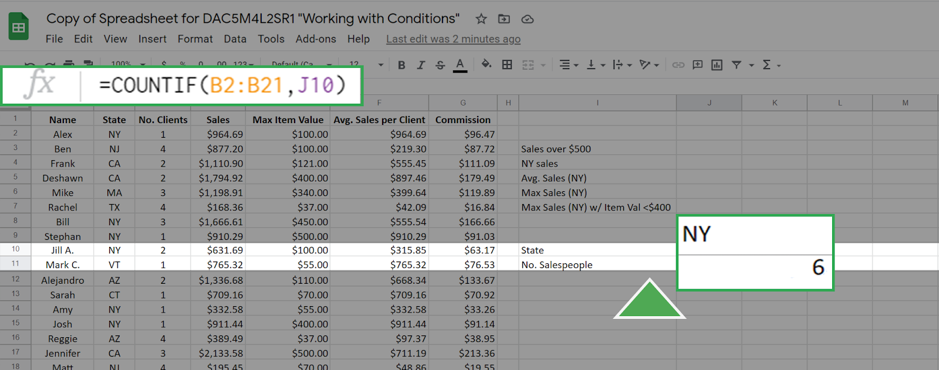

**You can achieve the same result by entering a cell address as the criteria**. For example, the cell J10 has the value "NY." If you enter this in the function bar the **COUNTIF** function will seek out the value in cell J10 and use it as the criteria. This gives the same result as before:

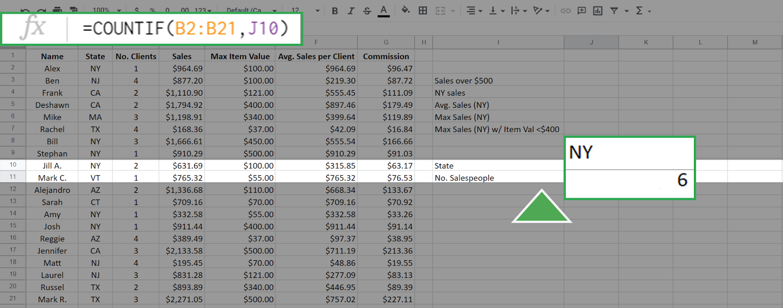

Other examples of using **COUNTIF** include a hotel manager checking on how many rooms are currently occupied for staffing and inventory, or it could be used in a factory to count the number of defective items in a batch.

### 

### **Step 3: Use the SUMIF function**

The **SUMIF** function is used to create a sum of the values of cells that meet a specific criteria. **SUMIF** supports the **logical operators** (>, <, <>, =). The syntax for this function is **=SUMIF(range, criteria, [sum_range] )**.

The range, also called the input range, is the array of cells that you check against the value of criteria. The **sum_range** is the array of values that you will sum up if the criteria is met. **In this syntax above, the square brackets around sum_range indicate that this input is optional. However, you do not add square brackets when writing the function**. If the argument **sum_range** is absent, then the **SUMIF** will sum the values in range by default.

As an example of this function, suppose that you want to create a sum of all sales more than $500.00. This can be executed as **=SUMIF(D2:D21, ">500")**.

The result is 19007.61:

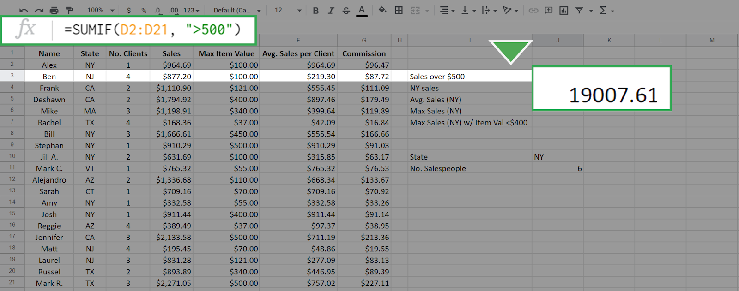

Because you didn't include the **sum_range** input, all the values in the cells D2 to D21 that match the criteria were summed by default. To sum only the sales from New York, but not restrict to those greater than $500, enter the following function: **=SUMIF(B2:B21, "NY", D2:D21)**.

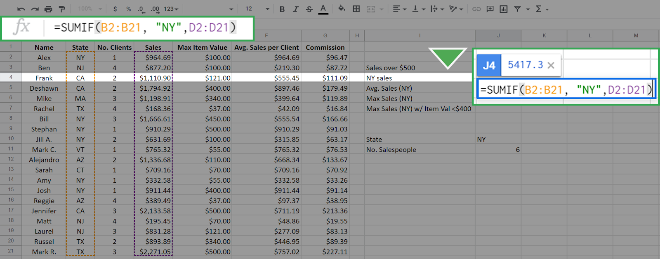

This results in 5417.3:

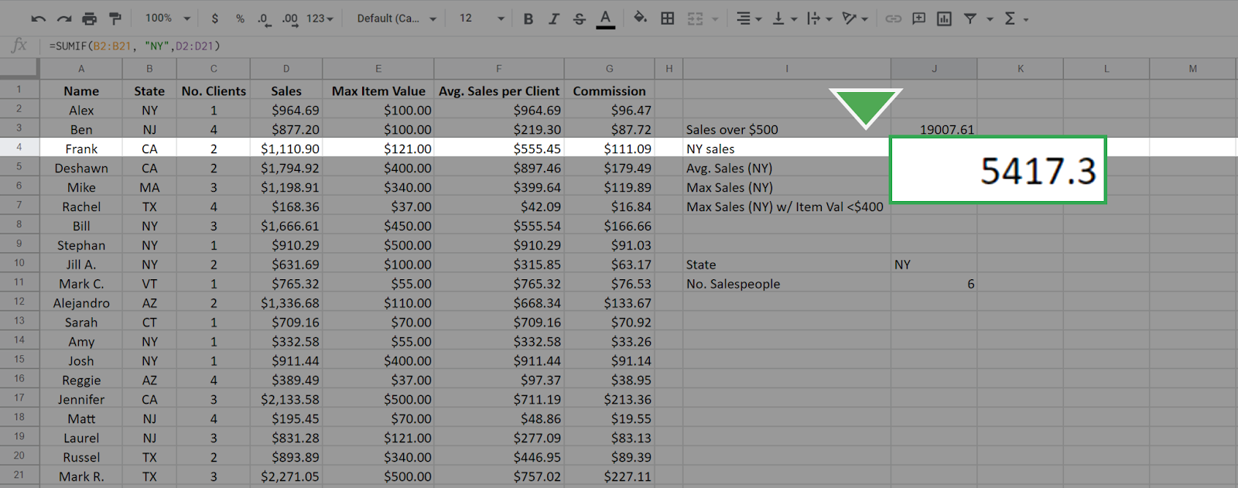

The first input, B2:B21, is the range of cells that are checked for the criteria "NY" and the summing is done across the **sum_range** of cells D2:D21 that have the state meeting the criteria "NY." This is different than in the first case. In that case, the array that you check is the same array that you sum across.

Other examples of using **SUMIF** include tracking the total value of a specific product to better manage inventory. A medical accountant might use **SUMIF** to total the expenses related to a particular department or piece of equipment, such as an MRI machine.

### 

### **Step 4: Use the AVERAGEIF function**

Just like the previous two functions, the **AVERAGEIF** function will average the values in an array based on a specific criteria. The syntax is **=AVERAGEIF(range, criteria, [sum_range])**.

The inputs to this function—**range**, **criteria**, and **sum_range**—work in exactly the same manner as in the **SUMIF** function. Again, the **sum_range** is optional.

You know from your previous queries that there are six salespeople in New York. To find the average sales per for these salespeople, enter the following function: **=AVERAGEIF(B2:B21, "NY", D2:D21)**.

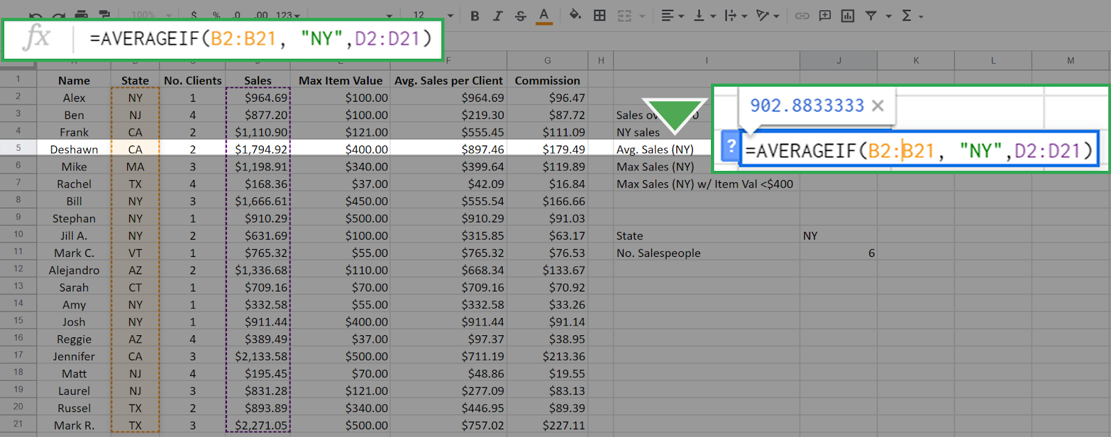

The result is 902.83333, which means that the average salesperson for this company in New York state sells $902.83 worth of merchandise.

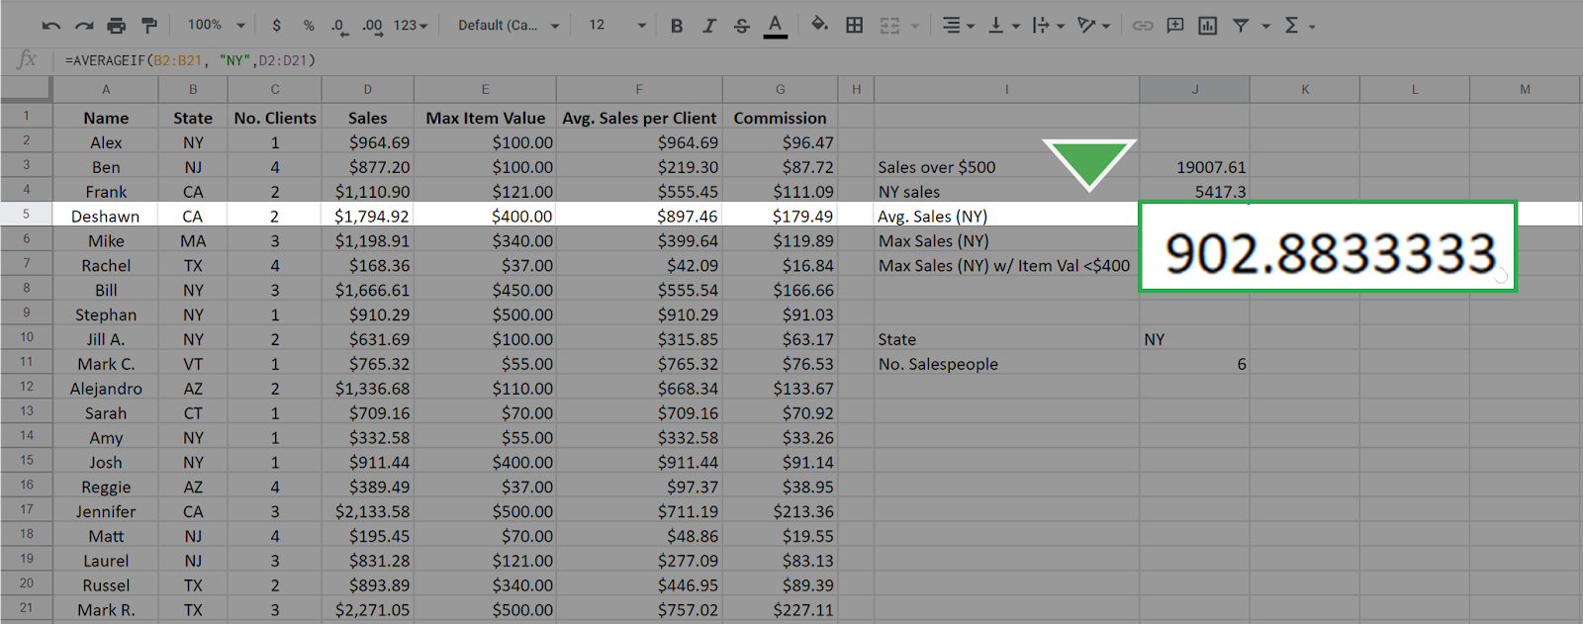

Averaging data conditionally allows you to get more specific insights into your dataset. For example, you might want to know the average sales that are made on weekends to plan promotional events more effectively.

### 

### 

### **Step 5: Use the MAXIFS function**

The **MAXIFS** function is slightly different from the other three functions—**it returns the maximum value in a range based on one or more conditions.**

The easiest way to observe the difference is to examine the **syntax: =MAXIFS(max_range, range1, criteria1, [range2], [criteria2], ...).**

Note for Microsoft Excel: **MAXIFS** can only be used with an Office 365 subscription on Excel 2016 or newer. If you cannot use a version of Excel that allows the function **MAXIFS**, use Google Sheets for this part of the activity.

1. The first argument, **max_range**, is the array for which you want to find the maximum value.
2. The second argument **(range1)** is the array you are checking.
3. The third argument **(criteria1)** is the value that you are checking for.
4. The inputs in the square brackets are for optional additional constraints.

To use **MAXIFS** to find the maximum sales from any salesperson in New York, enter the following: **=MAXIFS(D2:D21, B2:B21, "NY")**.

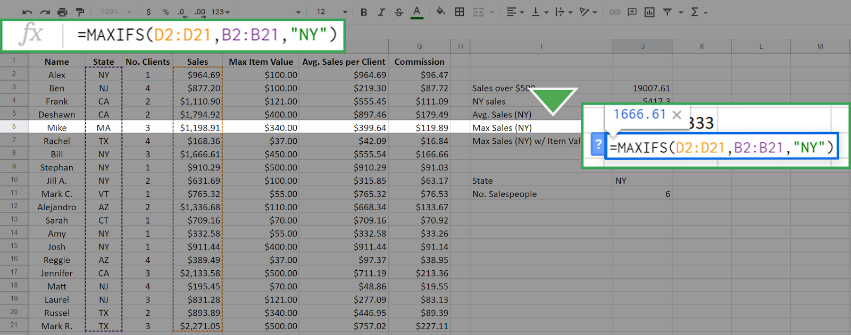

The resulting calculation is 1666.61. It’s important to keep in mind that the order in which you enter the inputs matters. If you reverse the position of the arrays and enter **=MAXIFS(B2:B21, D2:D21, "NY")** the result is 0.

This is because you are now asking the function to find the maximum of the array B2:B21 where the sales equal "NY". This is impossible because the values in the array D2:D21 (the sales array) are numerical—none of them equals "NY." The function returns 0 when nothing in the range meets the criteria.

The **MAXIFS** **function can input more than one constraint.**

This is where the optional **range2** and **constraint2** come into play.

For example, to find the maximum sales in New York where the Max Item Cost is below $400, enter the following into the function bar: **=MAXIFS(D2:D21, B2:B21, "NY", E2:E21, "<400")**.

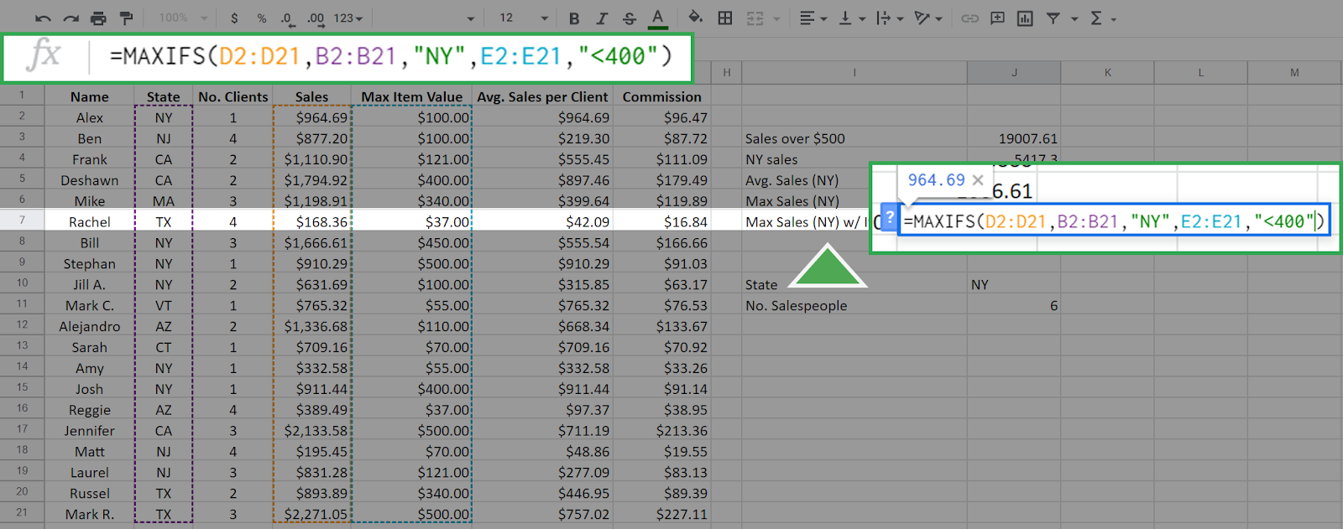

Additional constraints follow the logic that every constraint must be satisfied for a cell in the **max_range** to be considered.

The first three inputs are the same as above, but now you've added the additional constraint that Max Item Value must be less than $400. The array E2:E21 is the Max Item array and its cells are checked against the criteria <400. The function returns the following, which is the maximum sales of any New York salesperson who did not sell any single item over (or equal to) $400.

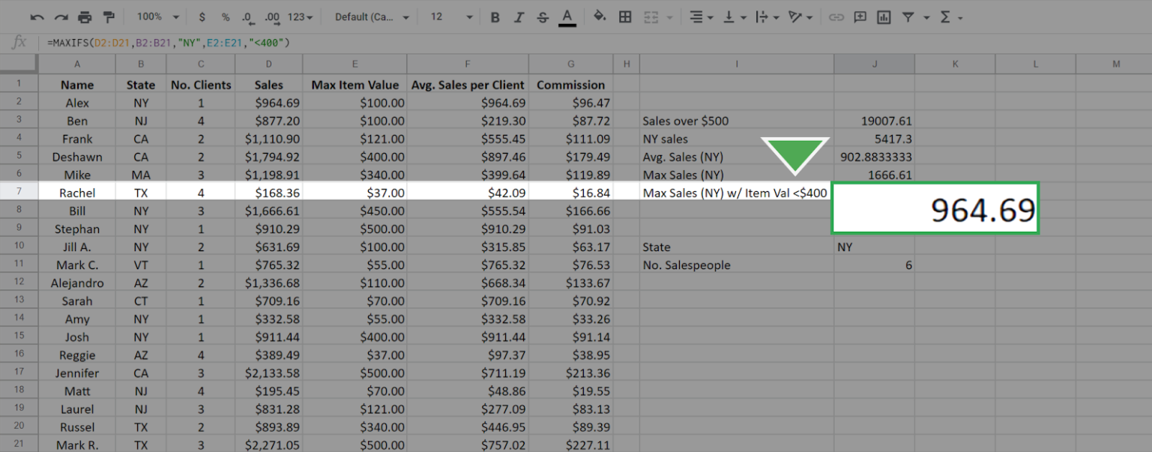

### 

### **Step 6: Compare the conditional functions**

Each of the previous functions—**COUNTIF**, **SUMIF**, and **AVERAGEIF**—have equivalents that work similarly to **MAXIFS**. These include **COUNTIFS**, **SUMIFS**, and **AVERAGEIFS**. The syntax and functionality of these functions, apart from the specific calculation, are identical to **MAXIFS**. For example, the **SUMIFS** function will give the sum for single and multiple constraints just like **MAXIFS** function does for the maximum. It also has the same syntax as **MAXIFS**

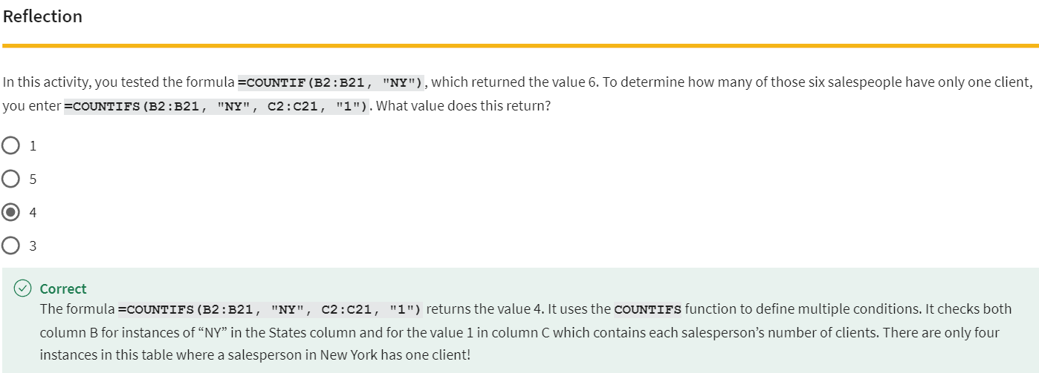

.

### [COMPOSITE FUNCTIONS](https://www.coursera.org/learn/analyze-data/lecture/VNgdu/composite-functions)

Data analysts love discovering new ways to work on their analysis, especially when those new ways simplify their work. I know I'm a big fan of learning new tricks to complete tricky tasks.

Instead of trying to find a new way to do something every time I do an analysis, I try to learn from other people by asking questions and getting help when I need it. **The people I work with like to use the phrase, stealing with pride**.

All this means is that you should feel no shame for using a process in your analysis that you learned from someone or somewhere else. Fellow team members, message board posts, online searches, I've used all of these resources for ideas. With pride! Of course, I always cite my sources when I do. That's a super important step to remember.

The SUMPRODUCT function is also one of those tricks that analysts come across either on their own or from another source. **You can also think of it as a shortcut for doing more complex calculations**. We'll show you how SUMPRODUCT works and when you might use it to make your work life simpler.

**SUMPRODUCT is a function that multiplies arrays and returns the sum of those products.**

Here's what the SUMPRODUCT formula looks like;



An array is kind of like a range in a spreadsheet. But keep in mind, **an array is a collection of values in cells, not the cells themselves.**

**Use this table to follow the example below:**[KP Kitchen Supplies, Profit](https://docs.google.com/spreadsheets/d/1tew5mVmK-wkAxJVzS2nZul6IJvK4tdbDfm3IjJfVWsE/template/preview)

**When added to a formula, the SUMPRODUCT function multiplies each of the values in two or more arrays together**.

For example, each value in the array of cells B3 through B7 can be multiplied by its corresponding value in the array of cells C3 through C7. B3 times C3, B4 times C4, and so on.

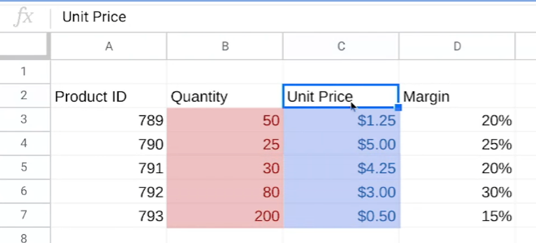

It will then return the sum of all of those multiplications.  
  
You might remember this example from our COUNTIF and SUMIF video.   
We've been given some data about a product order, including the quantity of each product that was sold in the order and the unit price, which tells how much one of each product cost. Our job is to use the data in these two columns to find out the total revenue for this order. That's where SUMPRODUCT comes in.

To find the total revenue, we need to do both addition and multiplication calculations. First off, we need to find the revenue that each item brought in separately. If we did this without SUMPRODUCT, we'd have to multiply each quantity by its unit price: 50 times $1.25, 25 times $5, and so on. Then we'd have to add all of those revenue amounts together to get the total revenue.

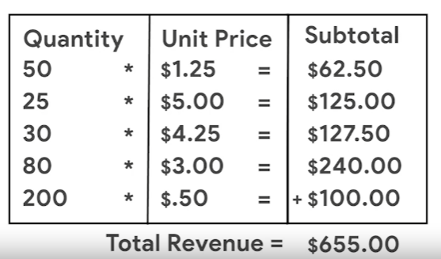

Fortunately, the SUMPRODUCT function does all of that for us. Let's add the label Total Revenue in cell G5 and then click G6 to input our formula. We'll then start our formula with an equal sign and the function followed by an open parenthesis. It's good to remind ourselves that the arrays we add to our formula should always be inside the parentheses. Next, we'll select cells B3 through B7 for the first array followed by a comma. The comma acts as a separator between the two arrays and the formula. Then, we'll select cell C3 through C7 for the second array, followed by a closed parenthesis to complete our formula. We don't need to include the brackets in our actual formula. We included them in the syntax example to clearly define each array for you. Then we press Enter to get our total revenue.

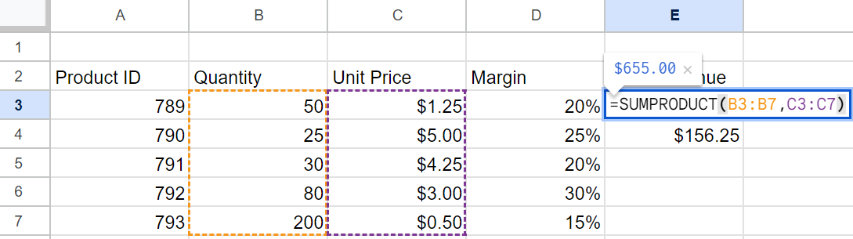

Since we're dealing with revenue, we'll format the number as currency. We've learned the total revenue is $655.

But that's not the actual profit from the sales of these kitchen supplies because we haven't included the profit margin in our calculations. The profit margin is a percentage that indicates how many cents of profit have been generated for each dollar of sale. In our dataset, product # 789 has a profit margin of 20 percent, meaning each product sold earns a total profit of $0.20 for every dollar. And just like the calculation for revenue, we can save time finding profit margin by using the SUMPRODUCT function. **There's only one difference between the formula for profit margin and revenue in this spreadsheet. But it's an important difference.** To start, in cell G7 we type the same first part of the formula. Then we include the two arrays in the same way as well.

But instead of ending our formula, we add another comma followed by another array. This time, we'll select the cells with a profit margin, D3 through D7. We'll finish our formula, and our calculation is complete.

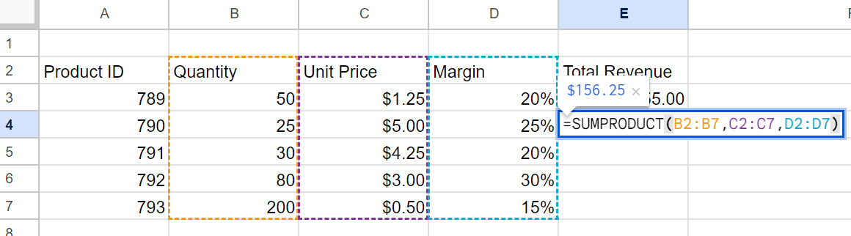

The SUMPRODUCT function saved us from having to multiply each individual revenue amount by each profit margin percentage, then add each profit margin amount together. Using SUMPRODUCT for calculations is a time-saver and helps you avoid making mistakes. Definitely a trick worth remembering, and there's more worth remembering about calculations coming up next.

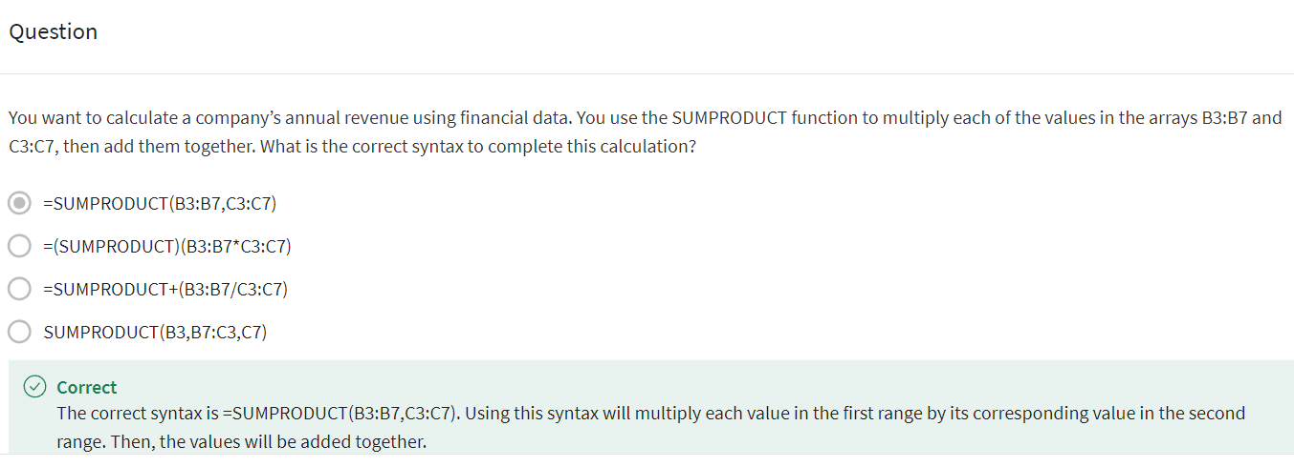

### [TEST YOUR KNOWLEDGE ON DATA CALCULATIONS](https://www.coursera.org/learn/analyze-data/quiz/HdCkh/test-your-knowledge-on-data-calculations)

### 

### 

## PIVOT…PIVOT…PIVOT…

### [START WORKING WITH PIVOT TABLES](https://www.coursera.org/learn/analyze-data/lecture/HCOme/start-working-with-pivot-tables)

By now, we've learned a lot about functions and formulas. **They are very helpful tools for your toolbox and great for finding shortcuts to complete calculations. But there's another tool out there that does some of the same things in a spreadsheet: the pivot table**.

As a quick reminder, pivot tables let you view data in multiple ways to find insights and trends. **We've talked before about how pivot tables help with cleaning and organizing your data including sorting and grouping data.**

**But pivot tables can also help with calculations. For example, they're great for quickly calculating sums and averages**.

Let's revisit our movie data set to show you how pivot tables and calculations worked hand in hand.

[Movie Data Starter Project](https://docs.google.com/spreadsheets/d/1FLaUmMn62YlHYihV6pK1DJqWcFYCnuoqoxFWmm_o5b0/template/preview)

Earlier, we summarized and organized this data in pivot tables. We'll do that here too. But in this case the organization is a bonus to using pivot tables for calculations. You can do these steps in Excel as well, though some of the steps might look different. If you're using Exce.

In this example, your manager asks you to find some trends to help them think through new movie ideas using revenue calculations. This spreadsheet has data about movies from several years ago. So it probably wouldn't be as useful right now.Still, the steps we take to analyze the data absolutely apply then and now. So let's get into it.

First, we need to find out how much revenue was generated each year. A pivot table is a good way to organize this.So we'll build a pivot table to show this. In our pivot table, we can also find the average revenue per movie. We can then check our findings for some possible trends.

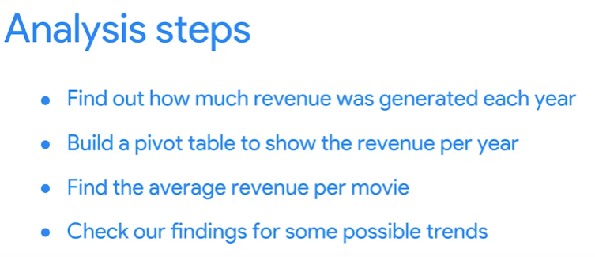

We'll start by finding the revenue generated each year. This gives us the release date for each movie in column B and the box office revenue in column N. Instead of reorganizing the table by year and building a formula to calculate the revenue per year we'll create a pivot table. Well, at the pivot table in a new sheet keeping the data range of cell A1 to cell N509.

Adding a new sheet is especially helpful when working in a large dataset like this. It helps keep our calculations together in one place and separate from the rest of the data.

We'll rename this sheet revenue to call out where our calculations are, both for ourselves and for anyone else on our team who might need our analysis. Now we can build our pivot table, starting with the rows.

We'll sort the rows by release date to find out the revenue for each year. You might notice this creates a row for every date on which one or more movies in this dataset was released.

Since we only need the years, we'll right click in one of the cells in the release date column to create a pivot date group and group by year.

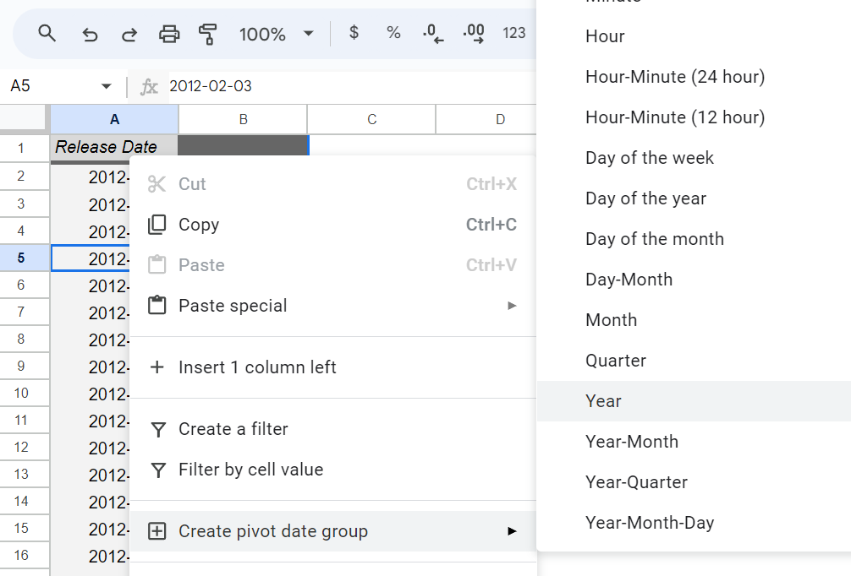

Now we have rows, one for each year in which these movies were released

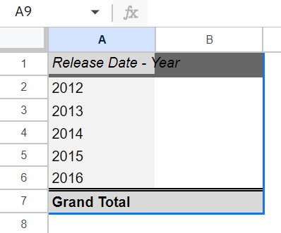

Next, we want to work with the values, add the box office revenue data on the Values field

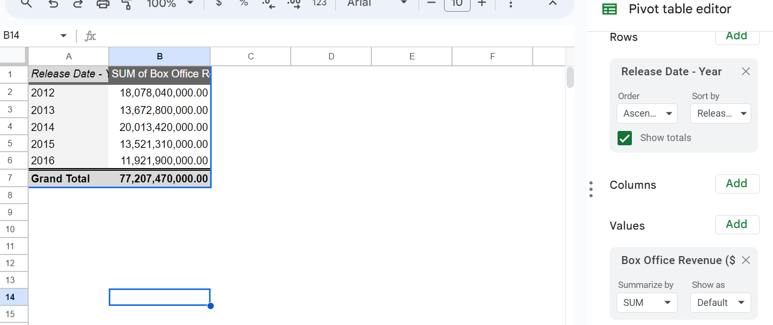

This populates the columns next to the release dates with the total box office revenue and each year. These calculations are automatic because the pivot table is already set to summarize the data using the sum function. So no need to change this setting.

There are other functions and are summarized by menu though, such as min for the minimum amount of revenue each year and count for the number of movies that generated revenue in each year.

Okay, let's check out what we've got here.

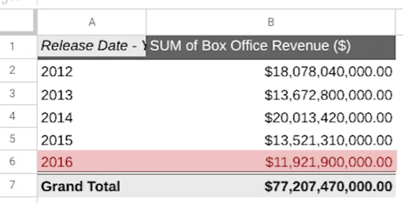

This data shows that 2014 has the highest revenue, while 2016 has the lowest. This might be useful information, but finding the average revenue per movie would most likely be more useful since there was a different number of movies released each year.

So we'll add another column for the average revenue earned by each year's movie. We can do this in the same pivot table. We'll add another value and change the function that we use to summarize from sum to average.

The average function gives us the average revenue per year for the movies in the dataset. We can see that the average revenue in 2015 was much lower than the other years.

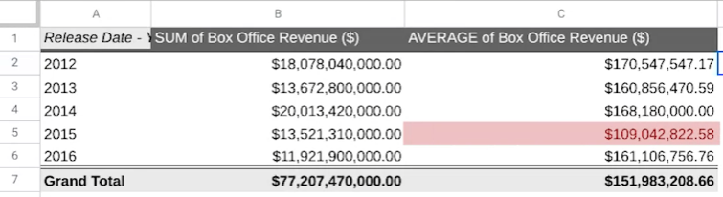

Since this data stands out so much, let's keep exploring to find out why.

Taking your analysis to another level like this is a sign of a great analyst. When you're in your job, you want to answer the questions that your manager and stakeholders ask. But you also want to answer the ones that come up while you're doing your analysis.

So let's try to figure this out. First, we'll know how many movies from each year were included in the dataset, we'll add a new value and use the count function this time.

This shows us that there are more movies in the data set from 2015 than from any other year. But 2015 still has the second lowest total box office revenue. This could mean a few things. It's likely that a lot of the movies from 2015 just didn't earn much revenue compared to the other years, which would bring down the overall average revenue. Even if the total revenue remained on par with the other years. We'll explore just this one possibility here. But you can always go further when you analyze data in your own job. It will depend on your objectives and the questions you need to answer. For now let's copy and paste our pivot table so we can test our hypothesis.We'll rename the columns and our copy table to differentiate them from our original table. We'll name them based on the data we'll be looking at, which I'll explain in the next video.

Now our copied pivot table is ready for us to test our hypothesis. Next, we're going to use filters to find out how many movies earned less than $10 million revenue in 2015. Then we'll also create a calculated field to determine what percentage of the total movies from that year they represent. I'll be here when you're ready to learn more about pivot tables.

### [PIVOT TABLES CONTINUED](https://www.coursera.org/learn/analyze-data/lecture/nXA6B/pivot-tables-continued)

In the last video, we created a pivot table of movie data and revenue calculations to help our manager think through new movie ideas. We used our pivot table to make some initial observations about annual revenue. We also discovered that the average revenue for 2015 was lower than other years even though more movies were released that year. We hypothesized that this was because more movies that earn less than $10 million in revenue were released in 2015. To test this theory, we created a copy of our original pivot table. Now we are going to apply filters in calculated fields to explore the data more. Let's get started. You all remember that the filter option lets us view only the values we need. We'll select a cell in our copied pivot table and add a filter to the box office revenue column. The filter will then be applied to the entire table. When we open the status menu, we can choose to filter the data to show specific values.

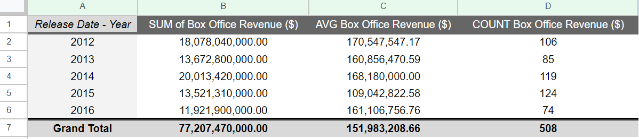

But in our case, we want to filter by condition so we can figure out how many movies in each year earn less than $10 million. The condition we'll use in our filter is less than and our value will be $10 million which is why we renamed these columns earlier. We'll type our number in a dollar and cents format so the condition matches the data in our pivot table. This might not be necessary, but it prevents potential errors from happening. Now we know that 20 movies released in 2015 made less than $10 million. This seems like a high number compared to the other years. But keep in mind, there were more movies from our data set released in 2015. Before we move on, let's use a calculated field to verify our average because it was copied from another pivot table before we filtered it. That way we can check that it's correct.

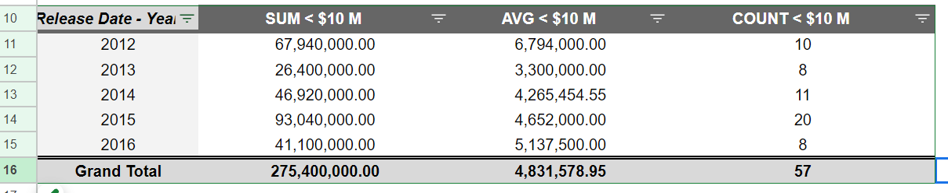

We'll create a customized column called a **calculated field** using our values menu. **A calculated field is a new field within a pivot table that carries out certain calculations based on the values of other fields.**

You can do this in Excel too using field settings and the create formula menu. For the formula in our calculated field, we'll use the sum function and divide the sum of the box office revenue data from our original table by the count of the same data. **=SUM('Box Office Revenue ($)')/count('Box Office Revenue ($)') —> Remember to set “Summarize by” to CUSTOM so your equation works properly.**

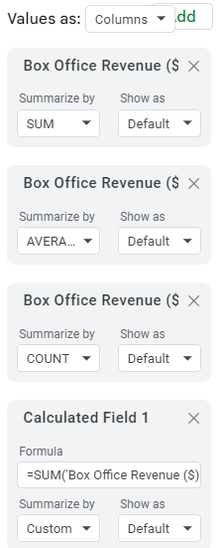

Because we applied our filter to this pivot table earlier, this formula will only return the average revenue of movies under $10 million. That worked. We were able to check the accuracy of some of our data before analyzing it. Always a good thing.

But it's still difficult to tell how much of an impact these lower earning movies had on the average revenue. Let's run a quick formula to find the percentage of movies for each year that earned less than $10 million. This will make it easier to compare from year to year.

Instead of a calculated field, we'll add this as a formula in a new column, that way we can pull data from both of our pivot tables

We'll put a header for our table in cell G10 and name it percent of total movies. Then we'll add our formula to the next cell in the column. Divide the number of movies in the copy table by the number of movies in the original table. Then we'll use the fill handle in the cell with a formula and drag it to apply the formula to the rest of the years. Finally, we'll format these numbers as percentages.

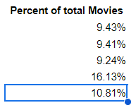

Now our analysis shows that 16 percent of the movies released in 2015 earned less than $10 million of revenue. The other years are all close to 10 percent.

This is one possible explanation for why the average revenue is comparatively low in 2015. In real life, we'd most likely need to take our analysis even further depending on our goals.

But for now, we're all set. **You've learned how you can use pivot tables to perform data calculations**.

**It will take practice, but pivot tables are worth it because they do more than calculate.** They organize and filter data too. Together we've covered functions, formulas, and pivot tables. All great tools to use in analysis.

With practice and experience, it will feel like you've used them forever. Just take your time getting to know how they work. Keep exploring these videos and the readings. Great work.

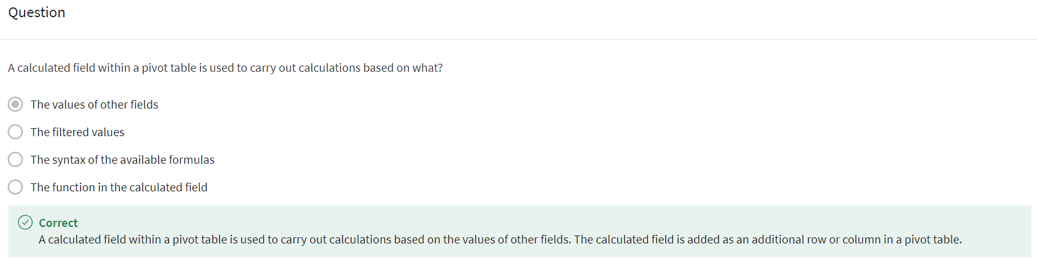

### [ELEMENTS OF A PIVOT TABLE](https://www.coursera.org/learn/analyze-data/supplement/j6w9Z/elements-of-a-pivot-table)

Previously, you learned that a pivot table is a tool used to sort, reorganize, group, count, total, or average data in spreadsheets. In this reading, you will learn more about the parts of a pivot table and how data analysts use them to summarize data and answer questions about their data.

**Pivot tables** make it possible to view data in multiple ways in order to identify insights and trends. They can help you quickly make sense of larger data sets by comparing metrics, performing calculations, and generating reports. They’re also useful for answering specific questions about your data.

A pivot table has four basic parts: rows, columns, values, and filters.

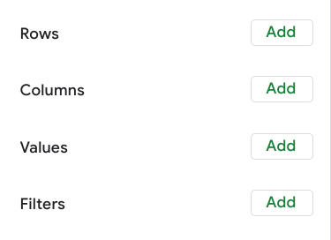

The **rows** of a pivot table organize and group data you select horizontally. For example, in the [Start working with pivot tables](https://www.coursera.org/learn/analyze-data/lecture/HCOme/start-working-with-pivot-tables) video, the Release Date values were used to create rows that grouped the data by year.

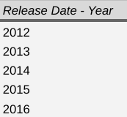

The **columns** organize and display values from your data vertically. Similar to rows, columns can be pulled directly from the data set or created using **values**. **Values** are used to calculate and count data. This is where you input the variables you want to measure. This is also how you create calculated fields in your pivot table. As a refresher, a **calculated field** is a new field within a pivot table that carries out certain calculations based on the values of other fields

In the previous movie data example, the **Values** editor created columns for the pivot table, including the **SUM** of Box Office Revenue, the **AVERAGE** of Box Office Revenue, and the **COUNT** of Box Office Revenue columns.

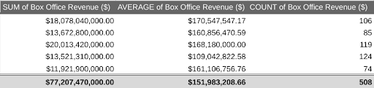

Finally, the **filters** section of a pivot table enables you to apply filters based on specific criteria—just like filters in regular spreadsheets! For example, a filter was added to the movie data pivot table so that it only included movies that generated less than $10 million in revenue.

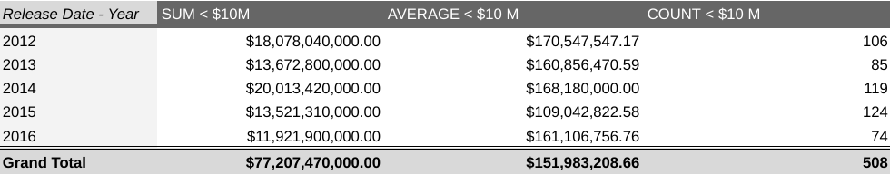

PS ESSA FOTO ACIMA ESTÁ MOSTRANDO DADOS ERRADOS, AS LABELS ESTÃO COMO A LABEL DA 2A PIVOT TABLE, MAS OS DADOS SÃO DA 1A PIVOT TABLE, O CORRETO DE ACORDO COM O VIDEO ANTERIOR SERIA:

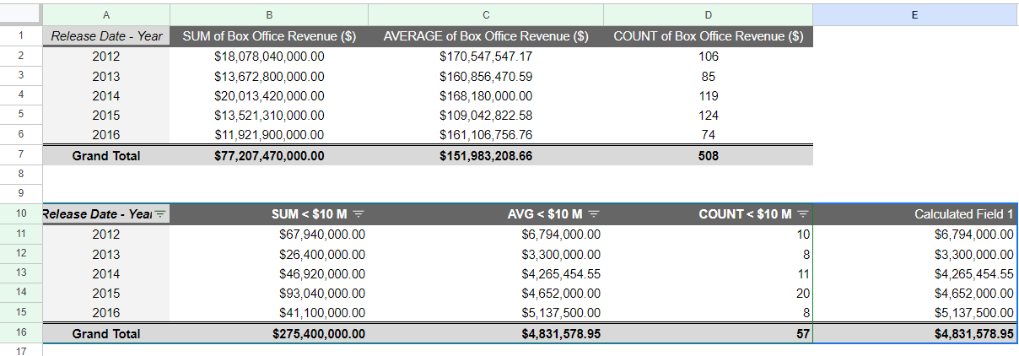

Being able to use all four parts of the pivot table editor will allow you to compare different metrics from your data and execute calculations, which will help you gain valuable insights.

## **Using pivot tables for analysis**

Pivot tables can be a useful tool for answering specific questions about a dataset so you can quickly share answers with stakeholders.

For example, a data analyst working at a department store was asked to determine the total sales for each department and the number of products they each sold. They were also interested in knowing exactly which department generated the most revenue.

Instead of making changes to the original spreadsheet data, they used a pivot table to answer these questions and easily compare the sales revenue and number of products sold by each department.

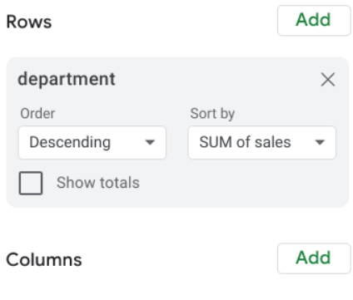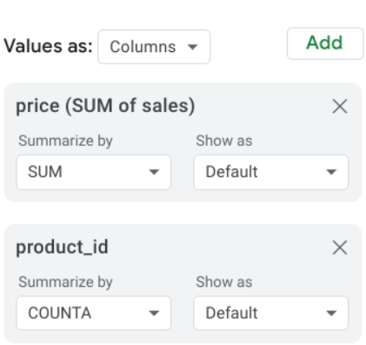

They used the department as the rows for this pivot table to group and organize the rest of the sales data. Then, they input two Values as columns: the SUM of sales and a count of the products sold. They also sorted the data by the SUM of sales column in order to determine which department generated the most revenue.

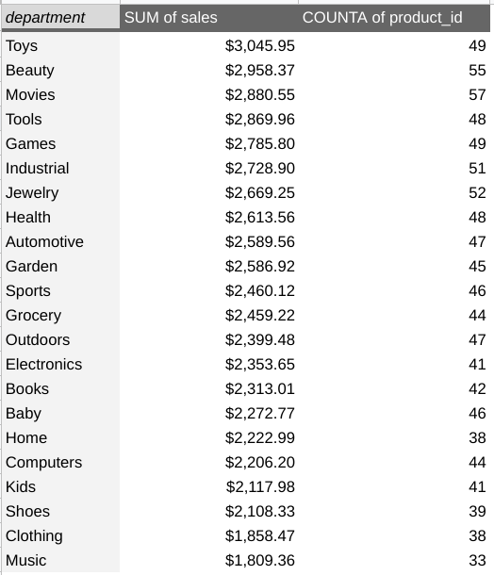

Now they know that the Toys department generated the most revenue!

## **Key takeaways**

**Pivot tables are an effective tool for data analysts working with spreadsheets because they highlight key insights from the spreadsheet data without having to make changes to the spreadsheet**.

Coming up, you will create your own pivot table to analyze data and identify trends that will be highly valuable to stakeholders.

### [USE PIVOT TABLES IN ANALYSIS](https://www.coursera.org/learn/analyze-data/supplement/qRo2l/use-pivot-tables-in-analysis)

In this reading, you will learn how to create and use pivot tables for data analysis. You will also get some resources about pivot tables that you can save for your own reference when you start creating pivot tables yourself. **Pivot tables** are a spreadsheet tool that let you view data in multiple ways to find insights and trends.

Pivot tables allow you to make sense of large data sets by giving you tools to easily compare metrics, quickly perform calculations, and generate readable reports. You can create a pivot table to help you answer specific questions about your data. For example, if you were analyzing sales data, you could use pivot tables to answer questions like, “Which month had the most sales?” and “What products generated the most revenue this year?” When you need answers to questions about your data, pivot tables can help you cut through the clutter and focus on only the data you need.

## 

## **Create your pivot table**

Before you can analyze data with pivot tables, you will need to create a pivot table with your data. The following includes the steps for creating a pivot table in Google Sheets, but most spreadsheet programs will have similar tools.

First, you will open the **Insert** menu from the toolbar; there will be an option for **Pivot table**.

This pop-up menu will appear:

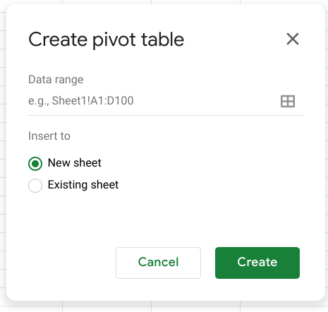

There is an option to select New sheet or Existing sheet and a Create button

Generally, you will want to create a new sheet for your pivot table to keep your raw data and your analysis separate. You can also store all of your calculations in one place for easy reference. Once you have created your pivot table, there will be a pivot table editor that you can access to the right of your data.

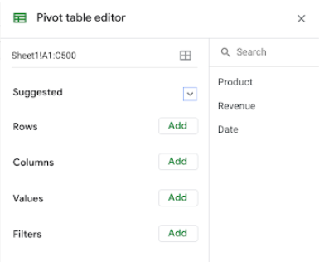

This is where you will be able to customize your pivot table, including what variables you want to include for your analysis.

## 

## **Using your pivot table for analysis**

You can perform a wide range of analysis tasks with your pivot tables to quickly draw meaningful insights from your data, including performing calculations, sorting, and filtering your data. Below is a list of online resources that will help you learn about performing basic calculations in pivot tables as well as resources for learning about sorting and filtering data in your pivot tables.

### 

### **Perform calculations**

| **Microsoft Excel** | **Google Sheets** |
| --- | --- |
| [**Calculate values in a pivot table**](https://support.microsoft.com/en-us/office/calculate-values-in-a-pivottable-11f41417-da80-435c-a5c6-b0185e59da77)**:** Microsoft Support’s introduction to calculations in Excel pivot tables. This is a useful starting point if you are learning how to perform calculations with pivot tables specifically in Excel. | [**Create and use pivot tables**](https://support.google.com/docs/answer/1272900?co=GENIE.Platform%3DDesktop&hl=en)**:** This guide is focused on using pivot tables in Google Sheets and it provides instructions for creating calculated fields. This is a quick how-to guide you can save and reference as a quick reminder on how to add calculated fields. |
| [**Pivot table calculated field example**](https://exceljet.net/pivot-table/pivot-table-calculated-field-example)**:** This resource includes a detailed example of a pivot table being used for calculations. This step-by-step process demonstrates how calculated fields work, and provides you with some idea of how they can be used for analysis. | [**All about calculated field in pivot tables**](https://infoinspired.com/google-docs/spreadsheet/all-about-calculated-field-in-pivot-table-in-google-sheets/)**:** This is a comprehensive guide to calculated fields for Google Sheets. If you are working with Sheets and are interested in learning more about pivot tables, this is a great resource. |
| [**Pivot table calculated fields: step-by-step tutorial**](https://powerspreadsheets.com/pivottable-calculated-fields/)**:** This tutorial for creating your own calculated fields in pivot tables is a really useful resource to save and bookmark for when you start to apply calculated fields to your own spreadsheets. | [**Pivot tables in Google Sheets**](https://www.benlcollins.com/spreadsheets/pivot-tables-google-sheets/)**:** This beginner’s guide covers the basics of pivot tables and calculated fields in Google Sheets and uses examples and how-to videos to help demonstrate these concepts. |

### 

### **Sort your data**

| **Microsoft Excel** | **Google Sheets** |
| --- | --- |
| [**Sort data in a pivot table or PivotChart**](https://support.microsoft.com/en-us/office/sort-data-in-a-pivottable-or-pivotchart-e41f7107-b92d-44ef-861f-24430830450a)**:** This is a Microsoft Support how-to guide to sorting data in pivot tables. This is a useful reference if you are working with Excel and are interested in checking out how filtering will appear in Excel specifically. | [**Customize a pivot table**](https://support.google.com/docs/answer/7572895?co=GENIE.Platform%3DDesktop&hl=en)**:** This guide from Google Support focuses on sorting pivot tables in Google Sheets. This is a useful, quick reference if you are working on sorting data in Sheets and need a step-by-step guide. |
| [**Pivot tables- Sorting data**](https://www.tutorialspoint.com/excel_pivot_tables/excel_pivot_tables_sorting_data.htm)**:** This tutorial for sorting data in pivot tables includes an example with real data that demonstrates how sorting in Excel pivot tables works. This example is a great way to experience the entire process from start to finish. | [**How to sort pivot table columns**](https://infoinspired.com/google-docs/spreadsheet/pivot-table-columns-in-custom-order-in-google-sheets/)**:** This detailed guide uses real data to demonstrate how the sorting process for Google Sheet pivot tables will work. This is a great resource if you need a slightly more detailed guide with screenshots of the actual Sheets environment. |
| [**How to sort a pivot table by value**](https://exceljet.net/lessons/how-to-sort-a-pivot-table-by-value)**:** This source uses an example to explain sorting by value in pivot tables. It includes a video, which is a useful guide if you need a demonstration of the process. | [**Pivot table ascending and descending order**](https://medium.com/actiondesk/pivot-table-ascending-descending-order-in-google-sheets-and-excel-1-minute-ultimate-beginners-8f9f4c560492)**:** This 1-minute beginner’s guide is a great way to brush up on sorting in pivot tables if you are interested in a quick refresher. |

### **Filter your data**

| **Microsoft Excel** | **Google Sheets** |
| --- | --- |
| [**Filter data in a pivot table**](https://support.microsoft.com/en-us/office/filter-data-in-a-pivottable-cc1ed287-3a97-4e95-b377-ddfafe79fa8f)**:** This resource from the Microsoft Support page provides an explanation of filtering data in pivot tables in Excel. If you are working in Excel spreadsheets, this is a great resource to have bookmarked for quick reference. | [**Customize a pivot table**](https://support.google.com/docs/answer/7572895?co=GENIE.Platform%3DDesktop&hl=en)**:** This is the Google Support page on filtering pivot table data. This is a useful resource if you are working with pivot tables in Google Sheets and need a quick resource to review the process. |
| [**How to filter Excel pivot table data**](https://www.dummies.com/software/microsoft-office/excel/how-to-filter-excel-pivot-table-data/)**:** This how-to guide for filtering data in pivot tables demonstrates the filtering process in an Excel spreadsheet with data and includes tips and reminders for when you start using these tools on your own. | [**Filter multiple values in pivot table**](https://infoinspired.com/google-docs/spreadsheet/filter-multiple-values-in-pivot-table-sheets/)**:** This guide includes details about how to filter for multiple values in Google Sheet pivot tables. This resource expands some of the functionality that you have already learned and sets you up to create more complex filters in Google Sheets. |

### **Format your data**

| **Microsoft Excel** | **Google Sheets** |
| --- | --- |
| [**Design the layout and format of a PivotTable**](https://support.microsoft.com/en-us/office/design-the-layout-and-format-of-a-pivottable-a9600265-95bf-4900-868e-641133c05a80): This Microsoft  Support article describes how to change the format of the PivotTable by applying a predefined style, banded rows, and conditional formatting. | [**Create and edit pivot tables**](https://support.google.com/a/users/answer/9308944#group_data_in_a_pivot_table): This Help Center article provides information about how to edit a pivot table to change its style, and group data. |

Pivot tables are a powerful tool that you can use to quickly perform calculations and gain meaningful insights into your data directly from the spreadsheet file you are working in! By using pivot table tools to calculate, sort, and filter your data, you can immediately make high-level observations about your data that you can share with stakeholders in reports.

But, like most tools we have covered in this course, the best way to learn is to practice. This was just a small taste of what you can do with pivot tables, but the more you work with pivot tables, the more you will discover.

### [HANDS-ON ACTIVITY: EXPLORE MOVIE DATA WITH PIVOT TABLES](https://www.coursera.org/learn/analyze-data/quiz/vuioG/hands-on-activity-explore-movie-data-with-pivot-tables)



## **Activity overview**



In the previous video, you were introduced to pivot tables as a tool for quickly comparing metrics, performing calculations, and generating readable reports. In this activity, you’ll navigate an example of a workplace scenario where you will create a pivot table to answer stakeholder questions and visualize data.

By the time you complete this activity, you will be able to apply pivot tables in your own analysis projects. This will enable you to draw insights and create reports directly from your spreadsheets, which is important for your career as a data analyst.

Review the following scenario. Then complete the step-by-step instructions.

### Scenario

You are a data analyst working with a filmmaking company. The company is trying to identify what genre of film they should make next. In order to help them make this decision, your manager has asked you to answer the following questions:

* On average, how much money do movies make in each genre?
* On average, how much money is spent on a movie broken by genre?
* On average, which genre has the most profitable movies?

Pivot tables make answering these types of questions much quicker and more accurate when compared to doing these same calculations by hand!

### Step-By-Step Instructions

### Step 1: Access the Template

To get started, access the movie spreadsheet from the previous video.

Select the link to the movie spreadsheet to create a copy. If you don’t have a Google account, you may download the data directly from the attachments below.

Link to movie data: [movie data starter project](https://docs.google.com/spreadsheets/d/1FLaUmMn62YlHYihV6pK1DJqWcFYCnuoqoxFWmm_o5b0/template/preview)

OR

[Movie Data Starter Project](https://d3c33hcgiwev3.cloudfront.net/ZOfER4TwQWmuXwra1hGpnQ_bce2c1e4996a4245ae4da1964cbbb5e1_Movie-Data-Starter-Project.xlsx?Expires=1713139200&Signature=NzUmKKgE2eQAaqIhDepXh67kFpCx~W7O4B5DTYk7mjVIpsb4u6BUQuNLp3Rw2eb7nFkuKujWK6Nrtl1eeDQsX-XxTuVVrj4hsHpsWgmhR2nwsfNp7OZ48e9hyECIYDJYNuQPr85jdrEB35PlsUNePhzxYpLF1vOijfzYr7zpxC0_&Key-Pair-Id=APKAJLTNE6QMUY6HBC5A)

[XLSX File](https://d3c33hcgiwev3.cloudfront.net/ZOfER4TwQWmuXwra1hGpnQ_bce2c1e4996a4245ae4da1964cbbb5e1_Movie-Data-Starter-Project.xlsx?Expires=1713139200&Signature=NzUmKKgE2eQAaqIhDepXh67kFpCx~W7O4B5DTYk7mjVIpsb4u6BUQuNLp3Rw2eb7nFkuKujWK6Nrtl1eeDQsX-XxTuVVrj4hsHpsWgmhR2nwsfNp7OZ48e9hyECIYDJYNuQPr85jdrEB35PlsUNePhzxYpLF1vOijfzYr7zpxC0_&Key-Pair-Id=APKAJLTNE6QMUY6HBC5A)

### Step 2: Create Your Pivot Table

For this exercise, you will use Google Sheets to work with pivot tables. If you are using Excel, the interface might be different. However, the majority of the functions are similar.

First, you need to generate your pivot table:

1. Open the Movie Data Starter Project spreadsheet.

2. Navigate to the Movie Data sheet.

3. With your cursor in a non-blank field, select the Insert menu.

4. Select Pivot Table.

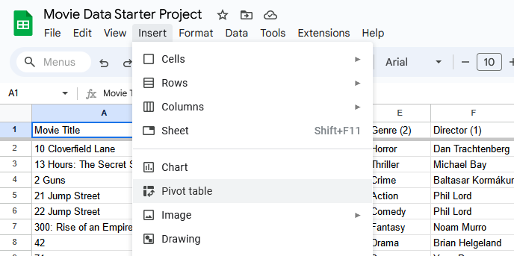

5. Verify the following Create pivot table settings:

a. Data range **= 'Movie Data'!A1:N509**

b. Insert to **= New Sheet**

6. Select Create.

7. In the newly created sheet, right-select on the tab and select Rename to rename the sheet to Summary.

8. Now, your Pivot table editor is likely going to be open on the right side of the screen.

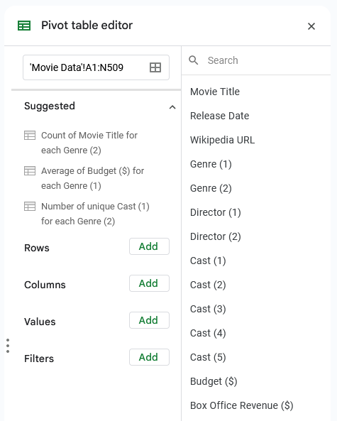

If the Pivot table editor isn’t already open, move your cursor over the pivot table area to reveal a small green pencil Edit icon. Select it to open the Pivot table editor.

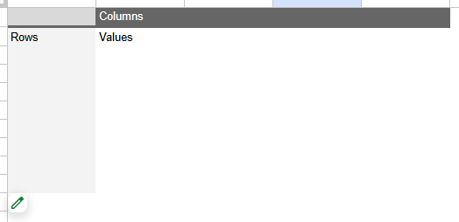

### Step 3: Find the Average Amount of Money Movies Make in Each Genre

In the Pivot table editor:

1. Select on the Add button to the right of the Rows section.

2. Select Genre (1).

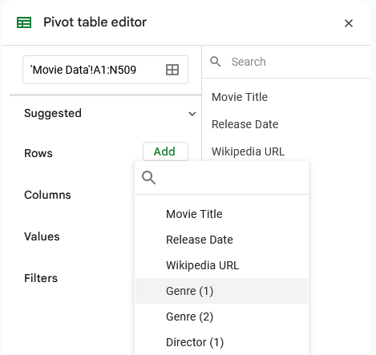

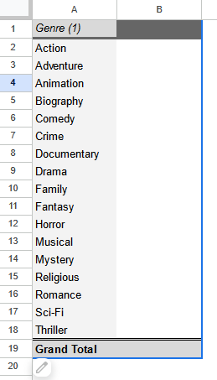

3. Next, select on the Add button to the right of the Values section.

4. Select Box Office Revenue ($).

5. In that smaller box, change the Summarize by selection by using the dropdown and changing the summarization from SUM to AVERAGE.

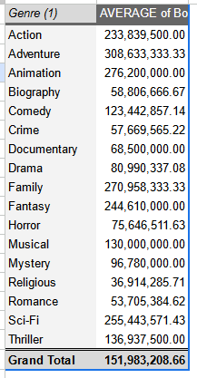

Now you have the breakdown of Average Box Office Revenue ($) by Genre.

### Step 4: Find the Average Amount of Money Spent on a Movie in Each Genre

Now, investigate the budget of these movies so you can compare them to the revenue you just calculated and determine their profit. Repeat the previous process to find the Budget ($):

1. Select on the Add button to the right of the Values section.

2. Select Budget ($).

3. In that smaller box, change the Summarize by selection by using the dropdown and changing the summarization from SUM to AVERAGE.

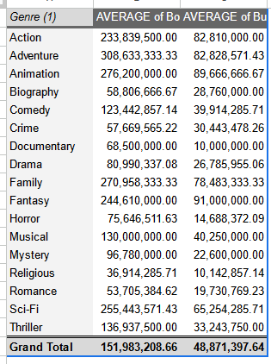

Now you have the average revenue and budget broken down by genre.

### Step 5: [Optional] Find the Genre that is Most Profitable on Average

Note: You may not be able to complete this part of the activity in Microsoft Excel. If you’re completing this activity in Microsoft Excel and do not find a Custom option in step 5.4, move on to step 6, complete the activity in Google Sheets, or use the resources provided earlier in this lesson to complete this step.

You can also use pivot tables to calculate profitability directly in the pivot table:

1. Select the Add button to the right of the Values section.

2. Select Calculated Field.

3. Copy and paste the following into the formula:

**=AVERAGE('Box Office Revenue ($)')-AVERAGE('Budget ($)')**

4. Change the Summarize by selection from SUM to Custom.

5. Select on cell D1 (in your Summary tab) and enter Average Profit to rename the newly calculated field.

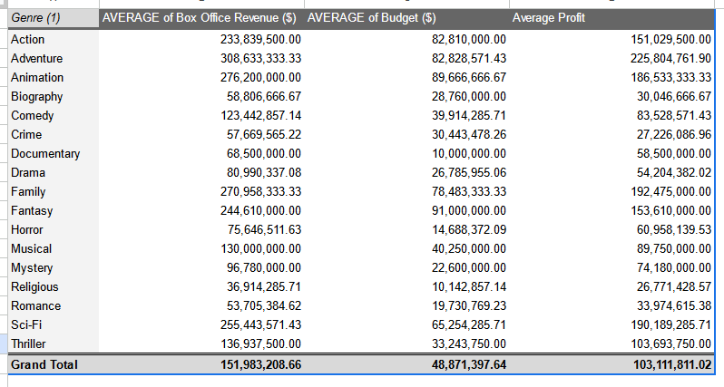

Perhaps your manager also asks you if there’s any way to sort the sheet to make it easier to identify which genres are most profitable. To do that, follow these steps:

6. In the Pivot table editor, go to the Genre (1) in your rows and update these settings:

a. For the Sort by dropdown, change the value from Genre (1) to Average Profit.

b. For the Order dropdown, change the value from Ascending to Descending.

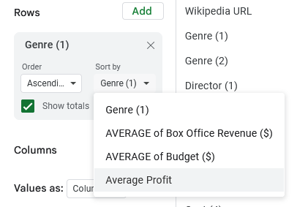

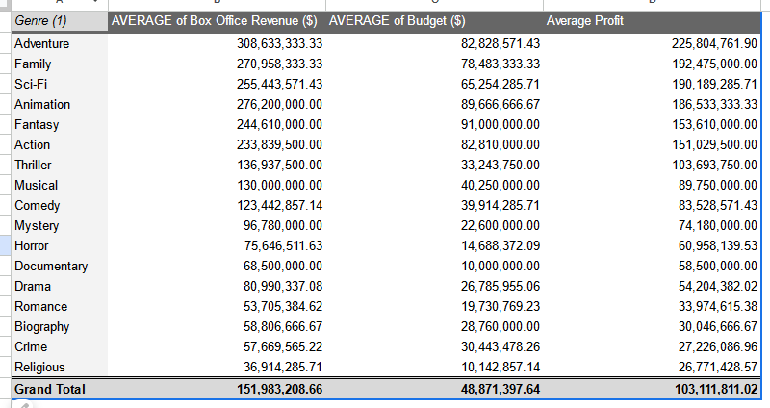

Here is that pivot table, now sorted to have the most profitable genres as the top of the list!

### Step 6: Visualize Your Data

Tables provide useful information, but visualizations can be even more effective for communicating data insights.

1. Select any cell in your pivot table.

2. Navigate to the Insert menu.

3. Select Chart.

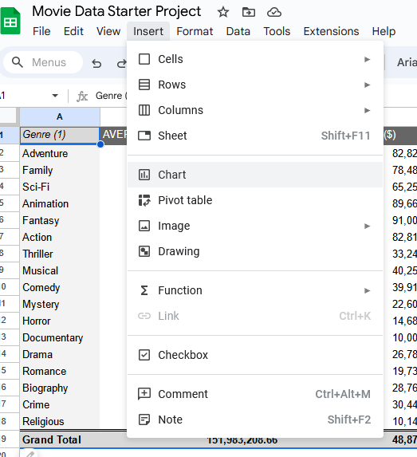

This creates a chart in the same worksheet as your pivot table.

4. Now, move the chart to the side of your table:

a. Select the chart.

b. Left-select in the chart and—while holding down your cursor—drag the cursor next to your table. This should move the chart with the movement of your cursor.

5. Next, set up your chart.

a. In the chart editor, navigate to Setup.

b. In the Setup window, change the Chart Type to Bar chart.

c. Under Series, select on the three dots to the right of AVERAGE of Budget ($).

d. Select Remove.

e. Next, under Series, select on the three dots to the right of AVERAGE of Box Office Revenue ($).

f. Select Remove.

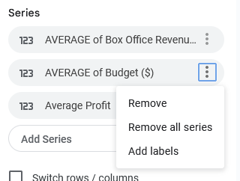

6. Next, customize your chart.

a. In the chart editor, navigate to Customize.

b. Under Chart & Axis Titles, select Chart title.

c. Change the chart title to Average Net Profit by Genre.

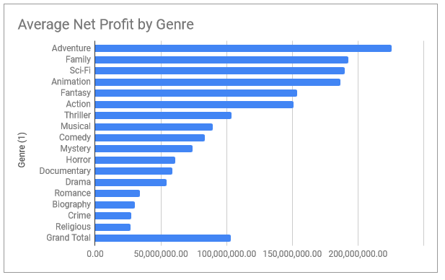

Great work! Now you have a visual that stack-ranks all of the movie genres by average profit.

Note: You may have noticed that there may be a Grand Total, which doesn’t appear to fall into the middle of your sorting. That’s okay! This is because it’s the total across all genres. You can choose to remove this by going back into your pivot table editor, in your Rows section, uncheck the Show totals box. This should automatically update any other references (charts or other) that were pointed at your pivot table!

### Pro Tip: Save the Activity Template

### Reflection

Using pivot tables, you were able to answer all three of your stakeholders’ questions about movie revenue, budget, and profit by genre! Not only that, you presented your findings in an organized way to make your findings clearer to your audience and provided them with a useful visualization.

Pivot tables are incredibly powerful. The ability to calculate these types of values will allow you to be more efficient in how you work, as well.

Pegadinha do malandro do caralho, pensei que era o maior profit por average e n mudei as infos na Pivot table Row

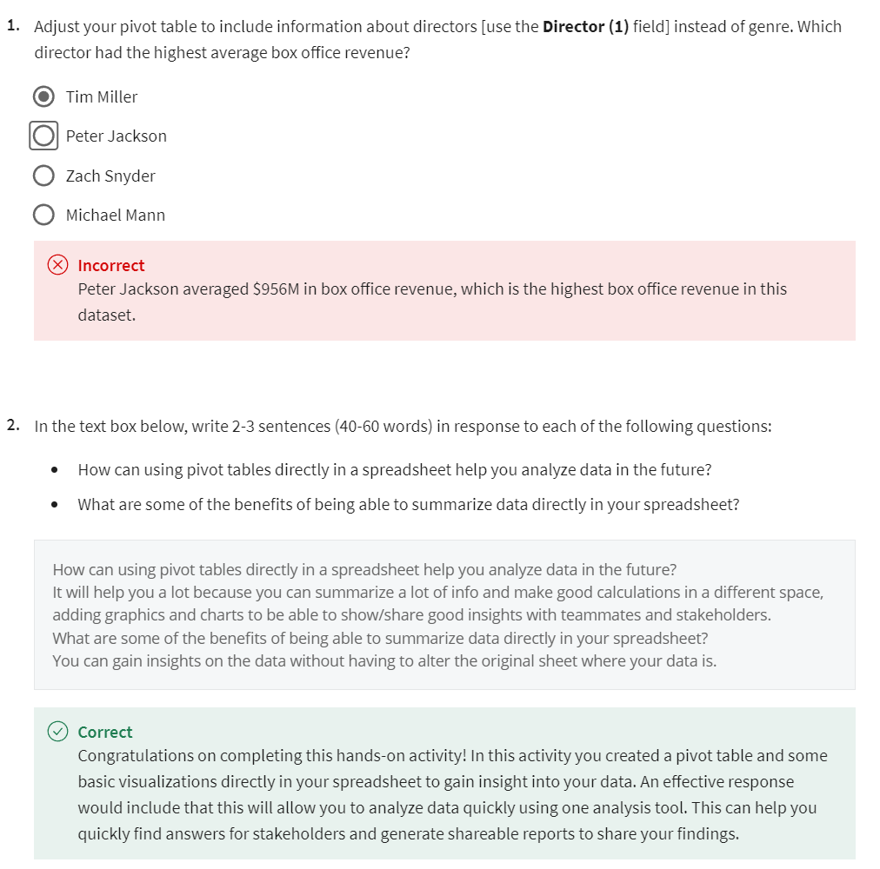

### [TEST YOUR KNOWLEDGE ON PIVOT TABLES](https://www.coursera.org/learn/analyze-data/quiz/Qs5pX/test-your-knowledge-on-pivot-tables)

## LEARN MORE SQL CALCULATIONS

## [QUERIES AND CALCULATIONS](https://www.coursera.org/learn/analyze-data/lecture/mUbhl/queries-and-calculations)

There's more than one way to do the daily task of a data analyst.Calculations are no exception. As we've shown in earlier videos, you can complete the same calculations in lots of different ways in spreadsheets. You can also complete them using SQL. In this video, we'll give you an overview of how SQL calculations compare to spreadsheet calculations.

Let's look at the arithmetic operators that are used in both spreadsheets and SQL. **An operator is a symbol that names the type of operation or calculation to be performed in a formula**.

As you learned earlier, the **four basic arithmetic operators** in spreadsheet formulas are the **plus sign for addition, the minus or hyphen for subtraction, the asterisk for multiplication, and the forward slash for division**. 

These same operators calculate data in the same way when writing queries in SQL. The operators are embedded in the queries when pulling data from a database. Just like spreadsheet formulas, there's a few different ways to perform calculations using queries.

Let's look at the syntax for one possible query. **The syntax of a query is its structure**. It should include all the specific details of the data you want to pull into a new table where those details should be placed. If you want to add values from two columns of a table, you start with the SELECT command, followed by the name of your first column, then the name of your second column. Then you'd add the names of both columns with a plus sign between them.

After that, you'd type AS followed by the name you'd like to give the column with the added totals. Finally, you then complete your query by typing FROM and then the name of the table that you're pulling the data from.

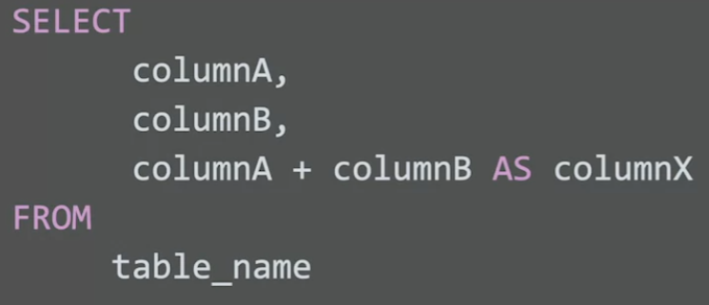

Running this query would get you a table showing the two columns whose values are being added together plus a new column showing the sums of those values.

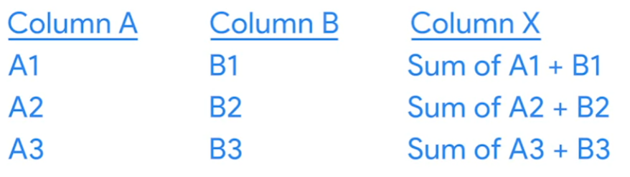

The operator in this query is a plus sign since values are being added. If you needed to subtract, multiply, or divide, you'd follow the same steps using the appropriate operators.

If you need to use more than one arithmetic operator in a calculation, you'd use parentheses to control the order of the calculations. If we included column C in our query, we could place parentheses around column A plus column B. We then add an asterisk if we're multiplying followed by column C.

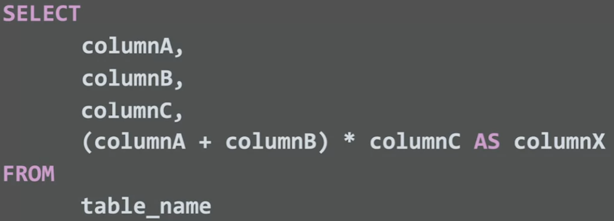

This query would return in a new column, the sum of the values in column A and B multiplied by the values in column C.

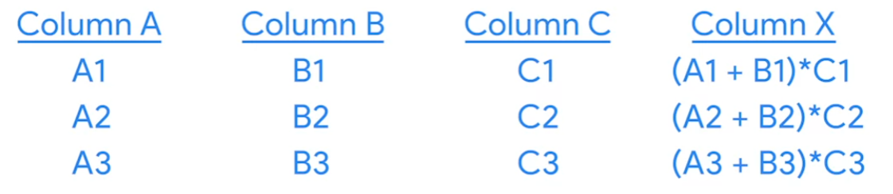

Now, let's say you only wanted the remainder from a division calculation. Well, you need a different operator for this, the modulo operator. The **modulo operator is represented by the percent symbol**. **This is an operator that returns the remainder when one number is divided by another. In a spreadsheet, you could complete the same calculation using the MOD function**.A lot of times, you can use functions instead of operators to complete calculations. For example, the SUM function can complete addition problems in spreadsheets and SQL. The AVERAGE function in a spreadsheet is the same as the AVG function in SQL.

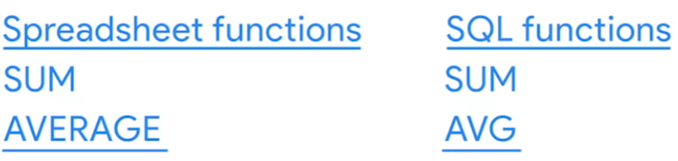

They both return the average value of a set of numbers. In SQL, these functions are considered aggregate functions because they perform a calculation on one or more values and return a single value. You'll learn more about how they're used with the GROUP BY command in a query soon. Those are the basics of SQL calculations. Knowing how to write a query for a calculation is a good first step. Stay with us, and you'll learn more about calculations in SQL. Bye for now.

## [UPLOAD THE AVOCADO DATASET TO BIGQUERY](https://www.coursera.org/learn/analyze-data/supplement/Y6c0d/upload-the-avocado-dataset-to-bigquery)

Using public datasets is a great way to practice working with SQL. Later in the course, you are going to use historical data on avocado prices to perform calculations in BigQuery. This is a step-by-step guide to help you load this data into your own BigQuery console so that you can follow along with the upcoming video.

## **Upload the avocado dataset to BigQuery**

In an upcoming video, the instructor demonstrates how to embed simple calculations in SQL. For this example, they use a publicly available Avocado Prices dataset from Kaggle. Follow the directions below to upload the avocado dataset to BigQuery. Once you’ve uploaded this data, you’ll be able to practice with this data on your own!

**Step 1:** Download the publicly available dataset [Avocado Prices from Kaggle.](https://www.kaggle.com/datasets/neuromusic/avocado-prices) This data has been made available by [Justin Kiggins](https://www.kaggle.com/neuromusic) under an [Open Data Commons](https://opendatacommons.org/licenses/odbl/1-0/) license. Kaggle is a great resource for all types of data analytics resources, and there are also other public datasets on the platform that you can download and use.

**Note:** You will need to create a free account before downloading the zipped data files.

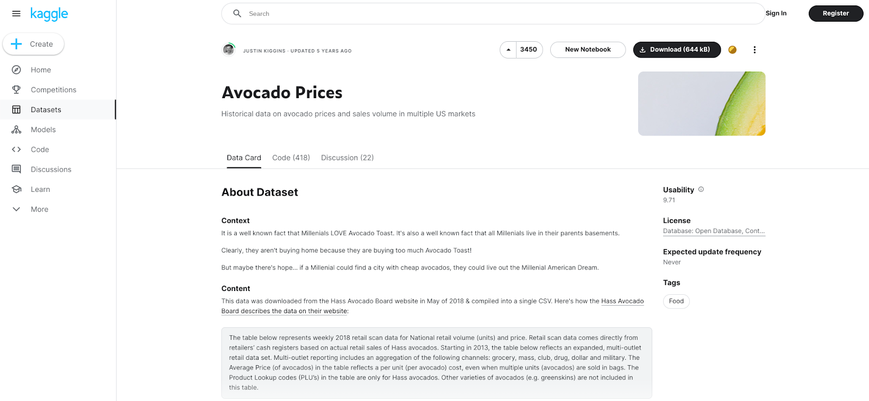

You will find some more information about the avocado dataset, including the context, content, and original source on this page. For now, you can simply download the file.

**Step 2:** Create the dataset.

1. After you have downloaded the dataset from Kaggle, extract the **zipped folder**. Remember where you save the avocado .csv file for upload into your BigQuery console.

2. Open your **BigQuery Console** and create a new dataset.

3. In the **Explorer** pane on the left side of your console, **select the project** where you want to add a dataset. Note that your project will have a unique name and won't be the same as the one in the example pictured below (loyal-glass-371423). If you already have it starred, don't choose bigquery-public-data as your project because that's a public project that you can't change.

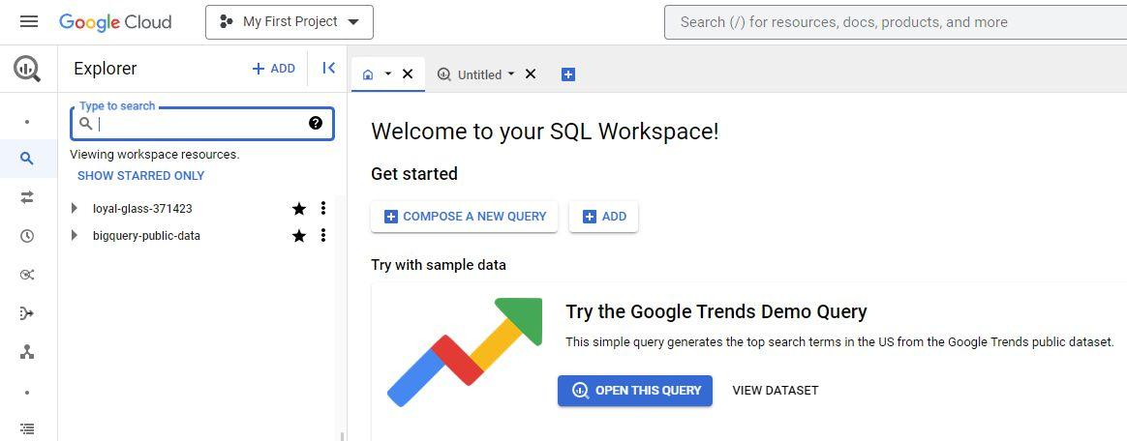

4. Select the **Actions** icon (three vertical dots) next to your project and select **Create dataset**.

5. Name the dataset **avocado_data**. In the **Location type** section, select **Multi-region,** then select **US (multiple regions in United States**, and make sure the default **Encryption** method within the **Advanced options** is set to the **Google_managed encryption key**. Then, select **Create dataset** (blue button) to create your new dataset. This will add data in the **Explorer** on the left of your console.

6. Navigate to the dataset in your console by expanding your project and selecting the correct dataset listed. In this case, it will be **avocado_data**.

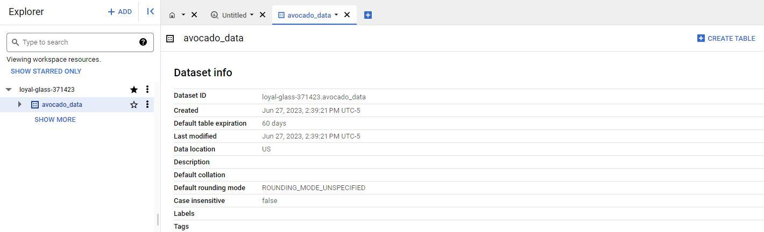

7. On the far right of the screen, select the blue **+ CREATE TABLE** button to open the Create table window. To fill out this window:

* Under **Source**, for the Create table from selection, select **Upload**.
* Click **Browse** to select the unzipped .csv file titled avocado you just downloaded to your computer from Kaggle. The **File format** should automatically change from **Avro** to **CSV** when you select the file.
* For **Table** name, enter **avocado_prices.**
* For **Schema,** click the **Auto detect** checkbox.
* Finally, to create the table, select **Create table** (blue button).

**Step 3:** Review the table information.

1. In the **Explorer**, the **avocado_prices** table will appear under the dataset you created.

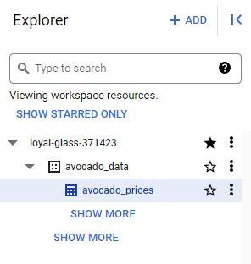

2. Select the table you created to develop a greater understanding of the table schema, details, and the data preview in the main editor window.

## [STEP-BY-STEP: EMBED SIMPLE CALCULATIONS WITH SQL](https://www.coursera.org/learn/analyze-data/supplement/NBGTM/step-by-step-embed-simple-calculations-with-sql)

This reading outlines the steps the instructor performs in the next video, [Embed simple calculations with SQL](https://www.coursera.org/learn/analyze-data/lecture/RlnmJ/embed-simple-calculations-in-sql). In this video, the goal is to find out the total number of bags of avocados sold on each date at each location using the dataset you loaded to BigQuery.

Keep this step-by-step guide open as you watch the video. It can serve as a helpful reference if you need additional context or clarification while following the video steps. This is not a graded activity, but you can complete these steps to practice the skills demonstrated in the video.

**What you’ll need**

In order to follow along with the instructor, you will need the [avocado dataset](https://www.kaggle.com/datasets/neuromusic/avocado-prices) uploaded into your project space. If you haven’t already uploaded this data, follow the instructions in the [Upload the avocado dataset to BigQuery](https://www.coursera.org/learn/analyze-data/supplement/Y6c0d/upload-the-avocado-dataset-to-bigquery) reading.

## 

## **Example 1: Verify the total number of bags**

Use the following steps to perform some simple calculations with SQL and verify the total number of bags.

1. Open the BigQuery editor.

2. On line 1, enter **SELECT** and press **Enter**. You'll use the **SELECT** command to pull certain columns from the table. Because you are selecting several columns, press **Enter** after **SELECT** and after the comma after each column name.

3. Enter the following column names into your editor:

4. Note the use of underscores in this example. Spaces can confuse certain servers and applications. Using underscores helps avoid potential issues while keeping the names readable.

5. Now add the calculation to the query using the names of the three columns with plus signs between them, as shown below. Add **_Calc** to your new column to compare the columns to each other after you calculate your results.

6.Finally, finish the query with **FROM** and the names of your project, database, and table:

**your-project.avocado_data.avocado_prices**.

**Note** that **your-project** is unique to you. If you haven't named it yourself, BigQuery assigns a name for you, typically in the form of two words and a six-digit number, each separated by a hyphen (for example, **loyal-glass-371423**). In the code examples throughout this reading, be sure to replace **your-project** with your unique project name.

SELECT

Date,

Region,

Small_Bags,

Large_Bags,

XLarge_Bags,

Total_Bags,

Small_Bags + Large_Bags + XLarge_Bags AS Total_Bags_Calc

FROM your-project.avocado_data.avocado_prices

7. Select **RUN** to run the query. Your query should return a table containing seven columns, as pictured here.

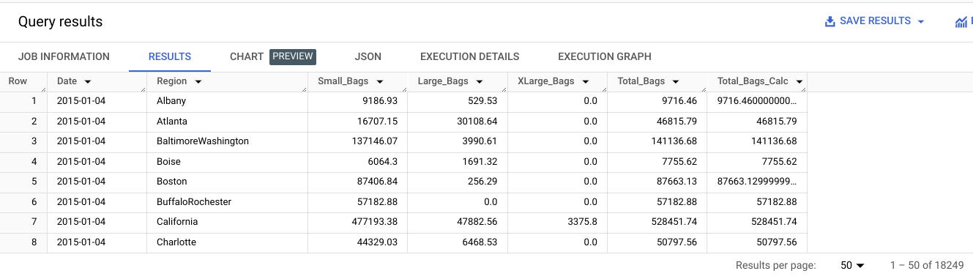

## **Example 2: Calculate the percentage of small bags**

Now that you have verified the total number of bags, you can use those values in another query. You need to find what percent of the total number of bags were small bags. This information might help stakeholders make decisions about how to package avocados or which size bag to run a sale on. Run a new query to calculate the percentage of small bags:

1. Create a new query.

2. Use the **SELECT** command to select the **Date**, **Region**, **Total_Bags**, and **Small_Bags** columns.

3. To find the percentage of small bags, divide the number of small bags by the number of total bags using a slash (**/**) as the operator. Put this part of the calculation in parentheses to let the server know that this calculation should be performed first. Then add **\*100** to give a percentage versus a decimal.

4. Use the **AS** command to name this new column **Small_Bags_Percent**.

5. Add **FROM** and the dataset.

6. Select **RUN** to run the query.

7. The "division by zero" error is the result of values of zero in the **Total_Bags** column when used to calculate the percentage in line 6. Add a step to solve this. Use the **WHERE** command. **WHERE** lets you add a condition to your calculation. In this case, specify to perform the selection only on rows where the total number of bags does not equal zero: **WHERE Total_Bags <> 0**.

SELECT

Date,

Region,

Total_Bags,

Small_Bags,

(Small_Bags / Total_Bags)*100 AS Small_Bags_Percent

FROM

your-project.avocado_data.avocado_prices

WHERE

Total_Bags <>0

8. Select **RUN** to run the query again. Your query should return a table containing five columns, the last one being the one you created: **Small_Bags_Percent**, as depicted in the following screenshot. Notice your new column shows the percentage of the total bag count that is made up of small bags.

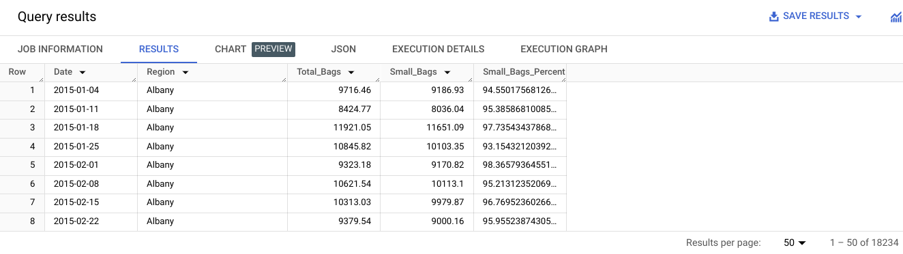

With SQL, you can complete just about any calculation you want during your analysis. Embedding the calculations in your queries will help you keep your analysis organized while getting your results. The methods shown here are just the beginning!

Mark as completed

## [EMBED SIMPLE CALCULATIONS WITH SQL](https://www.coursera.org/learn/analyze-data/lecture/RlnmJ/embed-simple-calculations-with-sql)

Same as previous topic, just the video explaining the same thing.

## [CALCULATIONS WITH OTHER STATEMENTS](https://www.coursera.org/learn/analyze-data/lecture/eiuvu/calculations-with-other-statements)

Hey, good to see you. As a data analyst, you'll find that your calculations come in all shapes and sizes. Earlier we showed you how to do some of the more basic calculations in SQL. While, basic calculations are great. **Sometimes you'll need to group data before completing calculations**.

The GROUP BY and ORDER BY commands help you do this. These commands are usually paired with aggregate functions like SUM or COUNT. We'll show you how you can use these commands and functions to calculate and summarize data from groups of rows in a table.

Let's explore the GROUP BY command first. **GROUP BY is a command that groups rows that have the same values from a table into summary rows**. The GROUP BY command is used with SELECT statements. In a basic SELECT FROM or SELECT-FROM-WHERE query, GROUP BY comes at the end of the query.



All right, let's try using GROUP BY. We'll work with a database, with data from a bike sharing system. We want to find out how many rides people took on these bikes per year.

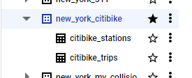

This data has several columns, but for this task, we only need the start time column.

Since this data set isn't organized by date, and the start time column isn't organized by year, we'll need to include steps in our code to organize it. We also want a total number of rides each year. So we'll need to include a calculation in our query for this. And depending on the questions we've been tasked with answering, this might be the first step of many in our analysis.

We'll start our query with the SELECT command. We'll then add EXTRACT to our query.

The EXTRACT command lets us pull one part of a given date to use. We'll extract the year from the start time column. To do this, we'll add an open parenthesis, followed by YEAR, which lets the server know the part of the date we need. Then we'll add the FROM command and STARTTIME so we can get the year from all of the start times in that column. We'll close the parentheses and then use AS and the word year to name the column we're creating.

On the next line of the query, we'll use the **aggregate function COUNT** followed by an asterisk in parenthesis. This will count the bike rides in the start time column. Using the asterisk makes sure that all the start times are counted in the data. Then we'll name our column number of rides with underscore between each word instead of spaces.

We will add FROM in the database we are pulling on the next line. In this case, that's bigquery-public-data.new_york.citybike_trips.

And here is our GROUP BY command. We'll use this to group the data by year. So we'll type GROUP BY followed by year.

We can further organize our results by using the ORDER BY command. Adding this after GROUP BY orders the results.

We'll add year to order the data by year. **It's good to note that by default, ORDER BY sorts data in ascending order.**

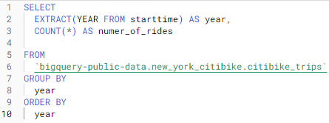

Now we can run our query to get the results.

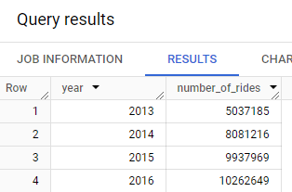

The years are ordered starting with 2013 and ending with 2016. If we want to change this to descending order, we can add the keyword DESC to the end of the query and run it again.

But whichever order you use, the **GROUP BY and ORDER BY commands are great for helping us complete and organize a calculation for our analysis.** This is one way to include calculations when aggregating data. And it's just one of many ways SQL helps keep your analysis running smoothly and moving forward. There's still more to come on calculations and SQL. Coming up, we'll learn more about data validation. See you soon.

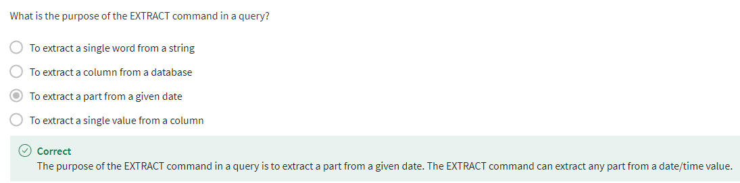

## [HANDS-ON ACTIVITY: CALCULATIONS WITH SQL](https://www.coursera.org/learn/analyze-data/quiz/IEXum/hands-on-activity-calculations-with-sql)



## **Activity Overview**



Previously, you learned about basic calculations with SQL. Just like spreadsheets, you can use the four basic arithmetic operations to perform addition, subtraction, multiplication, and division. Now, you’ll practice writing basic calculations using single and multiple operators in Bigquery. This will enable you to combine multiple arithmetic operations in a single query, allowing you to quickly and efficiently discover significant patterns in your data.

### 

### Step-By-Step Instructions

Follow the instructions to complete each step of the activity. Then answer the question at the end of the activity before going to the next course item.

### 

### Step 1: Access the dataset

For this activity, you’ll analyze subway ridership data to help improve the quality of the city’s public transportation. To do this, you’ll use data that describes the average weekly subway ridership in New York City from 2013-2018.

1. Navigate to your [BigQuery console](https://console.cloud.google.com/bigquery).

**Note:** BigQuery Sandbox frequently updates its user interface. The latest changes may not be reflected in the screenshots presented in this activity, but the principles remain the same. Adapting to changes in software updates is an essential skill for data analysts, and it’s helpful for you to practice troubleshooting. You can also reach out to your community of learners on the discussion forum for help.

### Step 2: Examine the dataset

1. Locate the public data by typing the word public in the search bar. Select SEARCH ALL PROJECTS and SHOW MORE to access all of the public datasets.

2. Select the star icon next to **bigquery-public-data**. This will pin it to the Explorer menu.

3. Select the dropdown arrow next to the bigquery-public-data to expand all the available datasets.

4. Navigate down the list until you find the **new_york_subway dataset**. Note: You may have to select the SHOW MORE button twice to reach the correct dataset. Now, select the dropdown arrow next to **new_york_subway** and select **subway_ridership_2013_present.**

**Note:** This dataset may not be accessible through other search methods. Follow the previous steps to locate the correct data for this activity.

Note also that any of the public databases on BigQuery are living records and, as such, are periodically updated with new data. Throughout this course (and others in this certificate program), if your results differ from those you encounter in videos or screenshots, there's a good chance it is due to a data refresh.

### Step 3: Use a calculation with a single operator

First, identify data exploring the change in weekly ridership from 2013 to 2014. Use SQL to subtract the number of riders in 2013 from the number of riders in 2014.

1. Select the dropdown arrow next to QUERY and select In split tab. You will then be able to see the Query editor and the datasets. If you prefer to only see the Query editor, you could select In new tab.

2. In the Query editor, add the names of the columns you want to use in your calculations in your **SELECT** statement. In this case, select the following columns:

* station_name
* ridership_2013
* ridership_2014

Be sure to add a comma after each column name. 2. Add the calculation to the query by adding the names of the two columns with a minus sign between them.

* ridership_2014 - ridership_2013

3. List the result in a new column. To do this, enter **AS** followed by the new column’s name. Name it change_2014_raw because it represents the change in ridership from 2013 to 2014 in raw numbers.

4. End your query with the **FROM** command and the name of the dataset and subset you’re pulling data from. After **FROM**, select Enter or Return and enter **bigquery-public-data.new_york_subway.subway_ridership_2013_present**.

SELECT

station_name,

ridership_2013,

ridership_2014,

ridership_2014-ridership_2013 AS change_2014_raw

FROM

bigquery-public-data.new_york_subway.subway_ridership_2013_present

5. Select RUN to get the results.

The results show the change in ridership from 2013 to 2014 at different stations. For example, the Atlantic Av - Barclays Ctr station gained an average of 1,774 riders per week. The 4 Av station lost 321 riders.

By including a basic calculation in your query, you can quickly gain important knowledge about your data. In this example, you now have insights into the change in ridership for each subway station in any given year.

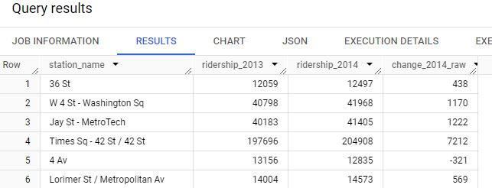

### 

### Step 4: Use a calculation with multiple operators

Next, find the average weekly ridership for a longer period of time, such as the multi-year period from 2013-2016.

To do this, combine multiple arithmetic operations in a query. The average of a set of numbers is the sum of the numbers divided by the total number of values in the set. There are four values in your new set (ridership data for 2013, 2014, 2015, 2016). Use SQL to sum the numbers for each year and divide that sum by 4.

1. Select the COMPOSE NEW QUERY button to refresh the query editor.

2. Enter **SELECT** to select the columns you want to pull from the table. You’re selecting several columns, so press Enter or Return after **SELECT** and add a comma after each column name. The columns selected for this query will be:

* enter station_name
* ridership_2013
* ridership_2014
* ridership_2015
* ridership_2016

3. Add the calculation to the query. Use parentheses to control the order of the operations if you use more than one arithmetic operator in a calculation. In this case, sum the years, then divide the sum by 4. Put parentheses around the sum of the four column names. Enter **(ridership_2013 + ridership_2014 + ridership_2015 + ridership_2016)**. Then enter a division operator / and the number 4.

4. List the result in a new column by entering **AS** followed by the new column’s name. Name the new average because it represents average weekly ridership for the period 2013-2016.

5. End your query with the **FROM** command and the name of the dataset and subset that you’re pulling data from. After **FROM**, select Enter and type:

**bigquery-public-data.new_york_subway.subway_ridership_2013_present**.

SELECT

station_name,

ridership_2013,

ridership_2014,

ridership_2015,

ridership_2016,

(ridership_2013 + ridership_2014 + ridership_2015 + ridership_2016)/4 AS average

FROM

bigquery-public-data.new_york_subway.subway_ridership_2013_present

6. Select RUN to get the results. The results clearly show the trend in ridership at each station from 2013 to 2016. 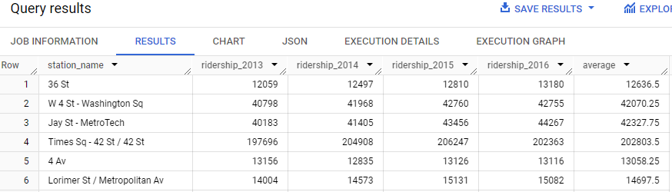

This kind of data is useful for managing public transportation. It can help you determine which stations or routes to expand due to increased ridership. Using basic calculations in your query allows you to quickly discover significant patterns in your data.

## [TEST YOUR KNOWLEDGE ON SQL CALCULATIONS](https://www.coursera.org/learn/analyze-data/quiz/CGpT6/test-your-knowledge-on-sql-calculations)\

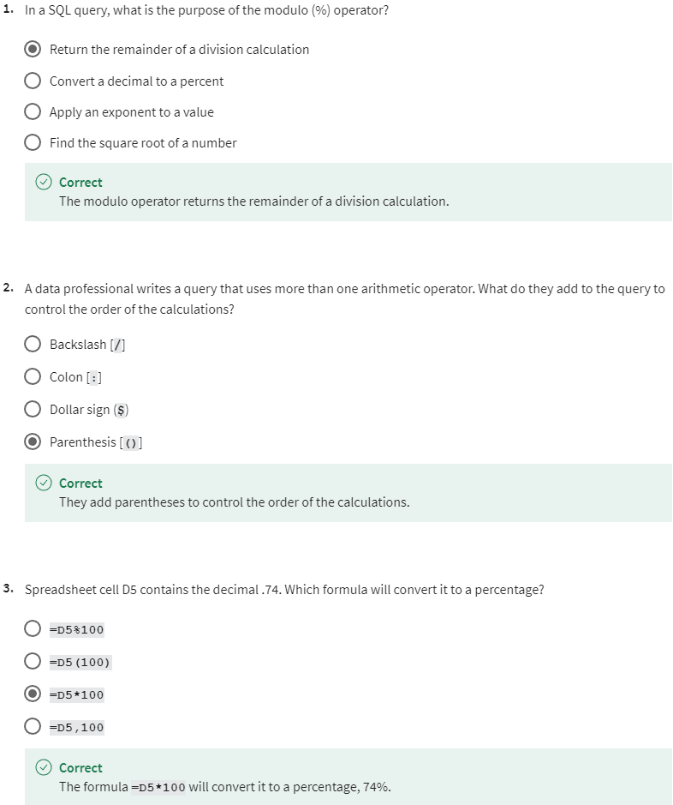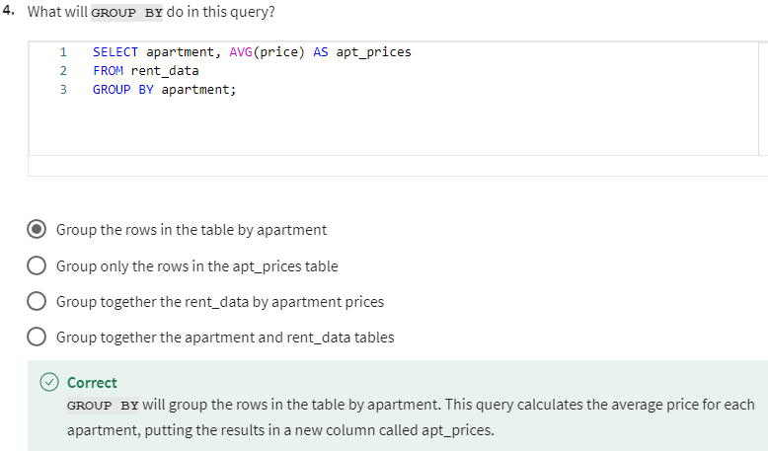

## THE DATA-VALIDATION PROCESS

## [CHECK AND RECHECK](https://www.coursera.org/learn/analyze-data/lecture/6tBpf/check-and-recheck)

Earlier we covered data validation, a spreadsheet function that adds drop down lists to cells. **Using data validation lets you control what can and can't be entered into your worksheet.** One of its uses is protecting structured data and formulas in your spreadsheets. But as useful as it is, the data validation function is just one part of a larger data validation process. This process involves checking and rechecking the quality of your data, so that it is complete, accurate, secure, and consistent. While the data validation process is a form of data cleaning, you should use it throughout your analysis.

If this all sounds familiar to you, that's good. Ensuring you have good data is super important. In my opinion, it's fun because you can pair your knowledge of the business with your technical skills. This will help you understand your data, check that it's clean, and make sure you're aligning with your business objectives. In other words, it's what you do to make sure your data makes sense. Keep in mind you'll build your business knowledge with time and experience.

**Here's a pro-tip, asking as many questions as possible whenever you need to will make this much easier**.

Let's say we're analyzing some data for a furniture retailer. We want to check that the values in the purchase price column are always equal to the number of items sold times the product price. We'll add a formula and a new column to recalculate the purchase prices using a multiplication formula.

Now comparing the totals, there's at least one value that doesn't match the value in the purchase price column. We need to find an answer to help us move forward with our analysis. By doing some research and asking questions, we find that there's a discount of 30% when customers buy five or more certain items. If we hadn't run this check, we could have missed this completely.

You've learned that as an analyst, calculations are a big part of your job. It's important that whenever you do calculations, you always check to make sure you've done them in the right way.

Sometimes you'll run data validation checks that are common sense checks. For example, let's say you're working on an analysis to figure out the effectiveness of in store promotions for a business that's only open on weekdays. You check to make sure that there's no sales data for Saturday and Sundays. If your data does show sales on weekends, it might not be a problem with the data itself. It might not even be a problem at all. There might be a good reason. Like maybe your business hosts special events on Saturdays and Sundays, then you would have sales for those weekends. You still might want to leave out the weekend sales in your analysis if your objective is only to look at the weekdays. But doing the state of validation might save you from miscalculations and other errors in your analysis. You should always do data validation no matter what analysis tool you're using. In an earlier video, we use SQL to analyze some data about avocados. One of the queries was a check to make sure the data showing the total number of bags was the sum of small, large, and extra large bags. By running this query, we were able to determine that the total number column was accurate. That led us to continue our analysis.

But when we tried to find what percent of the total number of bags was small, we ran into a small problem. We received an error message about dividing by zero. We fix that error by adjusting our query. If we had linked that query to a presentation that went to our stakeholders, they'd show us the divide by zero error instead of the figures we wanted. By building in these types of checks, as part of your data validation process, you can avoid errors in your analysis and complete your business objectives to make everyone happy. Trust me, it's a great feeling when you do.

Another great feeling is knowing that you've made it through another video and learned something new. We have more where that came from coming soon.

## [TYPES OF DATA VALIDATION](https://www.coursera.org/learn/analyze-data/supplement/tQAED/types-of-data-validation)

This reading describes the purpose, examples, and limitations of **SIX TYPES OF DATA VALIDATION**.

The **first five are** validation types **associated with** the **data**:

1. Data Type.
2. Data Range.
3. Data Constraint.
4. Data Consistency.
5. Data Structure)   
     
   The **sixth type focuses on the validation of application code** used to accept data from user input.

As a junior data analyst, you might not perform all of these validations. But you could ask if and how the data was validated before you begin working with a dataset. Data validation helps to ensure the integrity of data. It also gives you confidence that the data you are using is clean. The following list outlines six types of data validation and the purpose of each, and includes examples and limitations.



* **Purpose**: Check that the data matches the data type defined for a field.
* **Example**: Data values for school grades 1-12 must be a numeric data type.
* **Limitations**: The data value 13 would pass the data type validation but would be an unacceptable value. For this case, data range validation is also needed.



* **Purpose**: Check that the data falls within an acceptable range of values defined for the field.
* **Example**: Data values for school grades should be values between 1 and 12.
* **Limitations**: The data value 11.5 would be in the data range and would also pass as a numeric data type. But, it would be unacceptable because there aren't half grades. For this case, data constraint validation is also needed.



* **Purpose**: Check that the data meets certain conditions or criteria for a field. This includes the type of data entered as well as other attributes of the field, such as number of characters.
* **Example**: Content constraint: Data values for school grades 1-12 must be whole numbers.
* **Limitations**: The data value 13 is a whole number and would pass the content constraint validation. But, it would be unacceptable since 13 isn’t a recognized school grade. For this case, data range validation is also needed.



* **Purpose**: Check that the data makes sense in the context of other related data.
* **Example**: Data values for product shipping dates can’t be earlier than product production dates.
* **Limitations**: Data might be consistent but still incorrect or inaccurate. A shipping date could be later than a production date and still be wrong.



* **Purpose**: Check that the data follows or conforms to a set structure.
* **Example**: Web pages must follow a prescribed structure to be displayed properly.
* **Limitations**: A data structure might be correct with the data still incorrect or inaccurate. Content on a web page could be displayed properly and still contain the wrong information.



* **Purpose:** Check that the application code systematically performs any of the previously mentioned validations during user data input.
* **Example:** Common problems discovered during code validation include: more than one data type allowed, data range checking not done, or ending of text strings not well defined.

**Limitations:** Code validation might not validate all possible variations with data input.

## [HANDS-ON ACTIVITY: FROM SPREADSHEETS TO BIGQUERY](https://www.coursera.org/learn/analyze-data/quiz/tPlCp/hands-on-activity-from-spreadsheets-to-bigquery)



## **Activity Overview**



By now, you have worked with data using both spreadsheets and SQL. These tools operate very differently. In spreadsheets, you are able to observe and interact with data directly; with SQL, you interact with data through queries to the database. However, these tools also share a lot of the same functions. And they can even be used together on a project at different stages. In this activity, you’ll be presented with a business scenario where you will need to use a combination of spreadsheets and SQL to clean data, interact with a dataset using SQL, and export results into a new spreadsheet.

By the time you complete this activity, you will be able to combine tools to successfully analyze data. Switching between spreadsheets and SQL can be challenging because they’re so different, but being able to use them together can streamline your tasks as a data professional. Understanding how to use a given tool and when to use it will be critical when approaching larger and more complex projects in your career as a data analyst.

### 

### Scenario

Review the following scenario. Then complete the step-by-step instructions.

In this scenario, you are working as a data analyst for a national store chain. Management is interested in the amount of inventory being kept in storage at regional sites. Your supervisor has asked you to perform an analysis on inventory and sales data to make recommendations for changes to inventory management practices. You have been provided with three datasets containing information about inventory, products, and sales.

Before you upload these files to BigQuery, you'import them into a spreadsheet to get comfortable with the data and do an initial round of cleaning. To prepare them, you’ll import, inspect, and update the data so it’s useful once you upload it to your database.

These steps may not always be possible to conduct with spreadsheets when working with larger datasets you encounter in the future, but this use case allows you to explore which can be a helpful learning opportunity!

### Step-By-Step Instructions

### Step 1: Access the templates

To get started, download the three store data .csv files: inventory, products, and sales.

[Inventory](https://d3c33hcgiwev3.cloudfront.net/SUSio9QERM2RuGAeI9Or6Q_a35e3660fa944e7c80520d47bdd540e1_Inventory.csv?Expires=1713139200&Signature=Vy0RfmWRNDS7sGc8biJVmfoaHeKwTXOqeSnFbf-ecA418mkALwlfFiLwA-EXCh9MXcFzRBhzqq-cFLa~oKY2JE1-4vKmP5JUwemwGaC06lbc7RPV8v7S6dL4Oqu8hvzCQUP6XklTA0IQsr1O8602VWzfHH5kqKf5MnBuY9BtUFU_&Key-Pair-Id=APKAJLTNE6QMUY6HBC5A) and [Products](https://d3c33hcgiwev3.cloudfront.net/V5ttQHsxStaST_Ba0XA1pw_64f62fe38e0d4f47a8c3f9fc89ef65e1_Products.csv?Expires=1713139200&Signature=dSWulP8dtrvCl656hRHwn2UEzsX0HUT~XuJD-vPnsPbJANQ5uVc5Y5eYHHdGTlOGMInjVFZosNZTlejmzAgH7Q9D82re2REXGWQy7BfDJTwJrxlNaHS-6AlrFBLDEAXTdoRDHOBst9sJS8NVaTrCN2sJQuzsb2Ak2ZQJMKbNBk8_&Key-Pair-Id=APKAJLTNE6QMUY6HBC5A) and [Sales](https://d3c33hcgiwev3.cloudfront.net/rnTEkyDfTiGxp3gQ3UGv0w_6f35c5a482f14f4e84fec5944338ace1_Sales.csv?Expires=1713139200&Signature=dh1dA4L~~mr4zrboqMC0gfjuVC7aA7LyiG-R44p4gYsnHPSIFHvzJ6PcIcb0Jwycmo4581m0~OVJfRrIOM8HPvoot5yplbzWakWPP2OsXsaktPttsSJPDb8AaV-xh6GsHABbB~wBhF12s9-pJPOZeJ2SvhxMR4GglNMPHH4~kRc_&Key-Pair-Id=APKAJLTNE6QMUY6HBC5A)

### Step 2: Import the data into a spreadsheet

If you’re using Google Sheets, import the data files into your spreadsheet.

1. Open Sheets.

2. Navigate to the File menu.

3. Select Import from the dropdown list.

4. Select the first file and upload it to the spreadsheet.

5. Choose Replace spreadsheet to insert it into the current sheet.

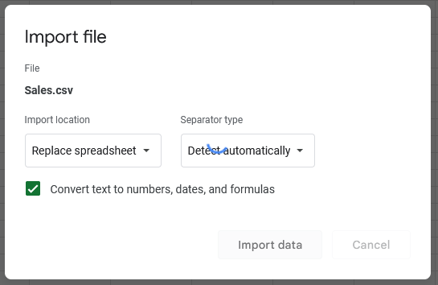

6. Return to the Import menu under the File menu and upload the next file. This time, however, select Insert new sheet(s) to create new worksheet tabs with this file.

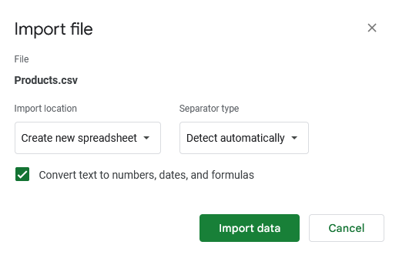

7. Repeat these steps until you have all three files added to your spreadsheet.

### 

### Step 3: Inspect the data in the spreadsheet

Applying filters in spreadsheets is an effective way to identify any data that needs to be cleaned. Start by inspecting the Inventory sheet.

1. Navigate to the Inventory sheet.

2. Select any non-blank cell.

3. Open the Data dropdown menu and select Create a filter.

4. Now you can select the filter icons for each column to inspect the values. Start with the StoreID column. As you scroll through, you might notice that there do not appear to be any blanks or incorrectly entered values. However, if you inspect the StoreName column, you’ll find a blank.

5. Deselect all of the values except for the blank.

6. Select the StoreName filter dropdown

7. Select Clear.

8. Select the checkbox next to the (Blanks) value in the list.

9. Select OK.

This should return one row with a missing entry under the StoreName column.

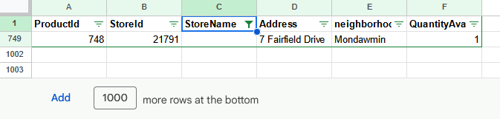

You might be able to find what the missing value is and input it correctly using the filter!

10. Clear the Storename filter and use the StoreId column filter for other stores with the ID 21791.

11. Copy the StoreID (21791)

12. Clear the StoreName Filter using the StoreName filter dropdown. Select Select All then OK.

13. Select the StoreId filter dropdown.

14. Select Clear.

15. Enter 21791 to the search bar which will pull up that StoreID.

16. Select the checkbox next to the 21791 value in the list

17. Select OK.

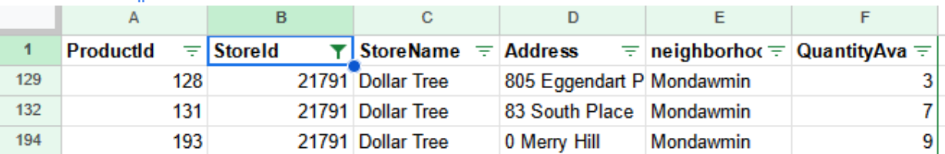

### 

### Step 3: Update the data in the spreadsheet

It appears that the other stores with this ID are all Dollar Tree, so it’s probably safe to input that as the StoreName value in the blank cell.

1. Enter Dollar Tree as the StoreName for that row (row 749).

2. Inspect the other columns in this sheet, then return to the Data menu to turn off the filters.

3. Next, navigate to the Products sheet. Similar to the last sheet, repeat this process to inspect the Products data.

Challenge: There is a problem with a ProductID column … try to find it. What should you do with it?

4. You'll find that there is a NA value in the ProductID column, despite the fact that this column should only have numeric values. In this case, you’ve checked in with the dataset owner, who said you can delete this row because it was input by mistake and does not belong in this dataset.

5. Turn off the filter and move on to the next step.

6. For the two datasets that you’ve updated (Inventory and Product), download those sheets as .csv files.

### 

### Step 4: Import data to BigQuery

Now that you have checked out your data in a spreadsheet that lets you observe and update your data directly, it’s time to transition to BigQuery so that you can interact with your data using SQL. As you’ve learned, SQL is used to fetch results from queries. While you can also use SQL to clean and update data, that is more commonly managed by database administrators or data engineers. For your purposes, SQL is very powerful when working with larger datasets, especially data in databases! In order to use SQL to query this data, you’ll need to import the data, explore it in your database, and then export the results.

Similar to previous activities, you will need to create a dataset and custom table to house this data before you can inspect it in BigQuery.

1. From the Explorer pane in your BigQuery console, select the three vertical dots next to your project space and select Create dataset.

2. Name the new dataset sales and leave the other settings as their default. Use these settings:

a. Under Location type, select Multi-Region, then select US (multiple regions in the United States).

b. Under Advanced options, select Google-managed encryption key for Encryption.

3. Once settings have been verified, select CREATE DATASET.

4. Open the new dataset (sales) info window by selecting the sales item under your project name. Find the row of tab commands.

5. From the sales dataset in your project, select CREATE TABLE.

6. Use the following settings to create your table:

a. Use the dropdown to set the Create table field to from = UPLOAD.

b. Select file = Sales.csv from your computer.

c. Set Table to sales_info

d. Select the checkbox under Schema for Auto detect.

e. Leave the default options on all for remaining options.

f. Select CREATE TABLE.

### Step 5: Explore the data in BigQuery

While you did your initial exploration of your datasets in a spreadsheet format, you’re going to continue inspecting your data using BigQuery with SQL. The goal in this section will be to gauge how much of the data will be useful for your analysis and work on putting it together in a useful way. If you haven’t already cleaned the data, exploring it now can be an opportunity to identify various ways to prepare it for analysis.

1. In the Explorer pane, select on the new table: sales_info.

2. Navigate through the SCHEMA and PREVIEW tabs.

3. Open a new QUERY tab.

4. Run the following query (placing your project name in the **FROM** statement):

SELECT

*

FROM [your_project_name_here].sales.sales_info

LIMIT 50

Your results will return something like this:

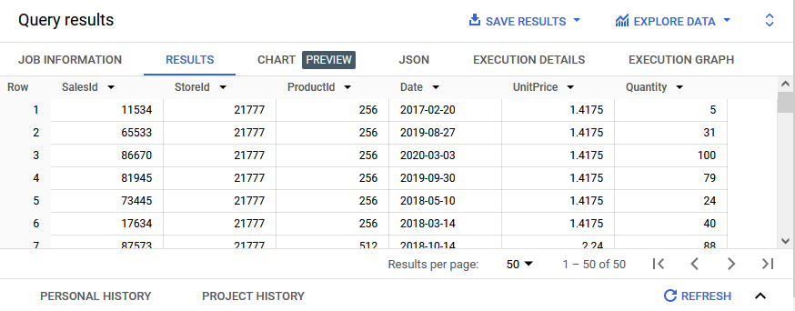

You’ve successfully run your first query! Now, check what kind of range of data you have in your dataset. Use **MIN** and **MAX** SQL functions to get the oldest and most recent dates with the following query:

SELECT

MIN(Date) AS min_date

, MAX(Date) AS max_date

FROM [your_project_name_here].sales.sales_info

From the query results, you’ll notice that sales_info contains sales from 1/1/2017 to 12/30/2020. Given that you are trying to synthesize an analysis for the sales data, you’ll begin aggregating data in a variety of ways.

As you work toward understanding this inventory and sales history, you will want to evaluate a few monthly sales stats. One question that you might want to be able to answer is: How many of each product is sold at each store at a given time?

One way to answer that could be using the following query:

SELECT

EXTRACT(YEAR FROM Date) AS YEAR --time grouping

, EXTRACT(MONTH FROM Date) AS MONTH --time grouping

, ProductId --need to know which products are sold

, StoreID --need to know which stores are selling

, SUM(quantity) AS UnitsSold --how many (impacts inventory)

, AVG(UnitPrice) AS UnitPriceProxy --can be interesting

, COUNT(DISTINCT salesID) AS NumTransactions --unique transactions can be interesting

FROM [your_project_name_here].sales.sales_info

GROUP BY YEAR, MONTH, ProductId, StoreID

ORDER BY YEAR, MONTH, ProductId, StoreID

This query will return the number of products the retailer sells. But you were also tasked with identifying how this relates to inventory. So, import (upload) the inventory dataset. You can add that as a table right in the sales dataset in BigQuery.

5. Under the actions (three dots) for the sales dataset, select Create Table). You can use these as your settings for the inventory table:

a. Create table from = UPLOAD (select dropdown option)

b. Select file = Inventory.csv (select your cleaned inventory file)

c. Table = inventory (this is the name of the table you’re creating)

d. Schema = Auto detect (select the check box)

e. Default options on all remaining options.

f. Select CREATE TABLE.

The previous query can be useful on its own for analysis, but you want to tie that to your newly imported inventory. Use this query:

Note: You’ll need to update your project name in two separate FROM statements.

with sales_history as (

SELECT

EXTRACT(YEAR FROM Date) AS YEAR --time grouping

, EXTRACT(MONTH FROM Date) AS MONTH --time grouping

, ProductId --need to know which products are sold

, StoreID --need to know which stores are selling

, SUM(quantity) AS UnitsSold --how many (impacts inventory)

, AVG(UnitPrice) AS UnitPriceProxy --can be interesting

, COUNT(DISTINCT salesID) AS NumTransactions --unique transactions can be interesting

FROM [your_project_name_here].sales.sales_info

GROUP BY YEAR, MONTH, ProductId, StoreID

)

SELECT

inventory.*

, (SELECT AVG(UnitsSold) FROM sales_history

WHERE inventory.ProductID=sales_history.ProductID

AND inventory.StoreID=sales_history.StoreID) AS avg_quantity_sold_in_a_month

FROM [your_project_name_here].sales.inventory AS inventory

This is a more advanced query! You don’t need to understand how it functions just yet, but you will definitely be able to use this query’s output.

For each ProductID + StoreId, you will find:

* The current inventory of every product for each store
* The average monthly quantity of a given product that was sold at that store

Now you’re ready to output a .csv file to bring back to management.

### Step 6: Export results to a spreadsheet

The subset of data in the query should be about 1,000 rows, based on the inventory list. This means that it can be easily exported to a spreadsheet. It’s important to ensure that you and your stakeholders both understand what it is they require (.csv or something else).

Save your results:

1. Within the query results, select SAVE RESULTS.

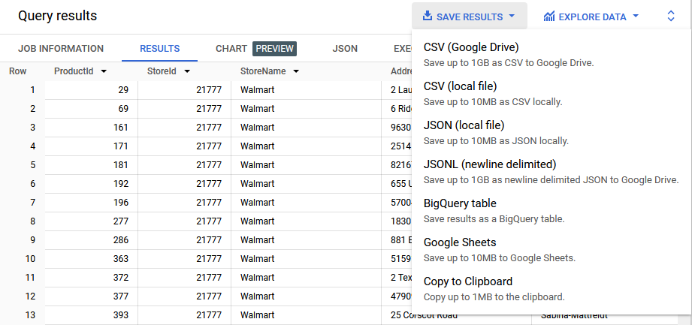

2. Choose CSV (Google Drive).

3. Once the job has completed, select GO TO DRIVE.

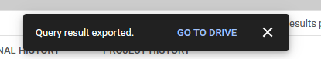

4. Using the Open with dropdown, select Google Sheets.

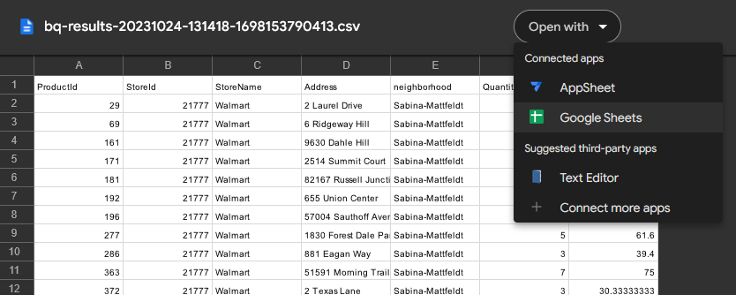

There should be about 1,000 rows.

5. Right-click on the sheet tab and rename the sheet inventory_with_avg_monthly_sales.

Now, you’re ready to share this with your stakeholder!

Note: If you closely examined the results of the last query, you would have noted that the avg_quantity_sold_in_a_month far exceeds the inventory’s QuantityAvailable in every row. This is where having a dialogue with your supervisor or stakeholder is so critical! At first, it may feel alarming because it seems the inventory at all of the stores are inadequate to meet the needs of the average quantities of their products sold. In such a situation, checking your work and having an open dialogue will allow you to approach your exploratory analysis effectively and deliver something useful to your audience.  
  
[START VALIDATING](https://www.coursera.org/learn/analyze-data/ungradedWidget/VomOd/start-validating)

## SQL AND TEMPORARY TABLES

## [TEMPORARY TABLES](https://www.coursera.org/learn/analyze-data/lecture/tMnmz/temporary-tables)

Now, if you're like me, you always have sticky notes available nearby to write a reminder or figure out a quick math problem. Sticky notes are useful and important, but they're also disposable since you usually only need them for a short time before you recycle them.

**Data analysts have their own version of sticky notes when they're working in SQL**. **They're called temporary tables** and we're here to find out what they're all about.

**A temporary table is a database table that is created and exists temporarily on a database server**. Temp tables as we call them store subsets of data from standard data tables for a certain period of time. Then they're automatically deleted when you end your SQL database session.

Since temp tables aren't stored permanently, **they're useful when you only need a table for a short time to complete analysis tasks, like calculations**.

For example, you might have a lot of tables you're performing calculations on at the same time. If you have a query that needs to join seven or eight of them, you could join the two or three tables having the fewest number of rows and store their output in a temp table. You could then join this temp table to one of the other bigger tables.

Another example is when you have lots of different databases you're running queries on. You can run these initial queries in each separate database, and then use a temp table to collect the results of all of these queries. The final report query would then run on the temporary table. You might not be able to make use of this reporting structure without temporary tables. They're also useful if you've got a large number of records in a table and you need to work with a small subset of those records repeatedly to complete some calculations or other analysis. So instead of filtering the data over and over to return the subset, you can filter the data once and store it in a temporary table. Then you can run your queries using a temporary table you've created.

Imagine that you've been asked to analyze data about the bike sharing system we looked at earlier. You only need to analyze the data for bike trips that were over 60 minutes or longer, but you have several questions to answer about the specific data.

**Using a temporary table will let you run several queries about this data without having to keep filtering it.** There's different ways to create temporary tables in SQL, depending on the relational database management system you're using. We'll explore some of these options soon.

For this scenario we'll use BigQuery. We'll apply a **WITH clause** to our query. The **WITH clause** is a type of temporary table that you can query from multiple times. **The WITH clause approximates a temporary table**. Basically, this means it creates something that does the same thing as a temporary table. Even if it doesn't add a table to the database you're working in for others to see, you can still see your results and anyone who needs to review your work can see the code that led to your results.

Let's get this query started. We'll start this query with the WITH command.

We'll then name our temp table trips, underscore, over, underscore, 1, underscore, hr. Then we'll type the AS command and an open parenthesis. On a new line, we'll use the SELECT- FROM-WHERE structure for our subquery. We'll type SELECT followed by an asterisk. You might remember the asterisk means you're selecting all the columns in the table. Now we'll type the FROM command and name the database that we're pulling from: bigquery, dash, public, dash, data, dot, new, underscore, york, dot, citibike, underscore, trips.

Next, we'll add a WHERE clause with the condition that the length of the bike trips we need in our temp table are greater than or equal to 60 minutes. In the query it goes like this: trip duration, space, greater than sign, equal sign, space, 60. Finally, we'll add a close parenthesis on a new line to end our subquery. And that sets up our temporary table.



Now we can run queries that'll only return results for trips that lasted 60 minutes or longer. Let's try one. Since we're working in our version of a temp table, we don't need to open a new query. Instead, we'll label our queries before we add our code to describe what we're doing.

**For this query, we'll type two hashtags. This tells the server that this is a description and not part of the code. Next, we'll add the query description.**

Count how many trips are 60 plus minutes long.

And then we'll add our query. SELECT, then on a new line COUNT with an asterisk in parentheses. As followed by cnt to name the column with our COUNT.

Next we'll add FROM and the name we're using for our version of a temporary table: trips over one hour.



When we run our query, the results show the total number of bike trips from the dataset that lasted 60 minutes or longer.

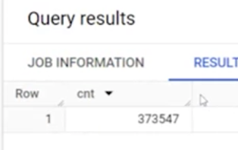

We can keep running queries on this temp table over and over as long as we're looking to analyze bike trips that were 60 minutes and over. And if you need to end your session and start a new runtime later, most servers store the code used in temp tables. You'll just need to recreate the table by running the code.

When you use temporary tables, you make your own work more efficient. **Naming and using temp tables can help you deal with a lot of data in a more streamlined way, so you don't get lost repeating query after query with the same code that you could just include in a temp table.**

And here's another bonus to using temp tables: **they can help your fellow team members too. With temp tables your code is usually less complicated and easier to read and understand which your team will appreciate!**

## [HANDS-ON ACTIVITY: CREATE TEMPORARY TABLES](https://www.coursera.org/learn/analyze-data/quiz/Ac9jc/hands-on-activity-create-temporary-tables)



## **Activity Overview**



As data calculations become more complicated, there are many components to keep track of, such as range, cost, time elements, products, and more. Some people use sticky notes for this, while others use checklists. In the data profession, a temporary table is just like a sticky note.

You learned about temporary tables in SQL in earlier lessons, so take a moment to review. Temporary tables, or temp tables, store subsets of data from standard data tables for a certain period of time. Temp tables allow you to run calculations in temporary data tables without needing to make modifications to the primary tables in your database. Because they are temporary, they are automatically deleted at the end of your SQL session.

By the end of this activity, you will have gained more experience creating temp tables and using them to run queries.

### 

### Scenario

Review the following scenario. Then complete the step-by-step instructions.

A bikeshare company has reached a milestone, and their marketing team wants to write a blog post announcing the popularity of their most-used bike. They want to include the name of the station where that bike can most likely be found, so they ask you to determine which bike is used most often.

### Step-By-Step Instructions

### 

### Step 1: Import your data

The first step is to import your data. For this activity, you will use a BigQuery dataset on bikesharing in Austin, Texas, which contains details about each public bike ride’s duration, starting station, and ending station.

To load your data, follow these steps:

1. Log into BigQuery and open your [Console](https://console.cloud.google.com/bigquery).

* Note: BigQuery frequently updates its user interface. The latest changes may not be reflected in the screenshots presented in this activity, but the principles remain the same. Adapting to changes in software updates is an essential skill for data analysts, and it’s helpful for you to practice troubleshooting. You can also reach out to your community of learners on the discussion forum for help.

2. Select the project dropdown list to open the Select a project dialog box.



3. In the Select a project dialog box, select the NEW PROJECT button.

4. Name your project something that will help you identify it later. You can give it a unique project ID or use an auto-generated one.

5. Now, access the Editor interface. You will use the Explorer menu to search for datasets.

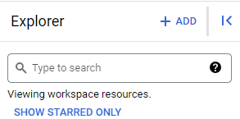

### 

### Step 2: Pin the dataset

Note: Before you can load the **austin_bikeshare** dataset, you need to have the bigquery-public-data pinned in the Explorer menu of your SQL Workspace. Follow these steps to pin the dataset:

1. Enter public in the Explorer menu search box and press the Enter key.

2. Select SEARCH ALL PROJECTS.

3. Scroll to find bigquery-public-data and select the star to pin it.

After you’ve highlighted the star and pinned the bigquery-public-data to the Explorer menu, you’ll need to add the Austin bike dataset. Follow these steps:

1. Select the arrow to the left of bigquery-public-data to expand its contents and scroll to find austin_bikeshare.

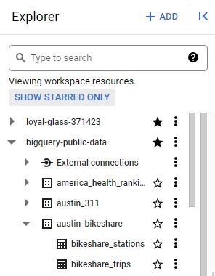

2. Expand austin_bikeshare and select bikeshare_trips.

3. Select the Preview tab in the viewer on the right to examine the dataset.

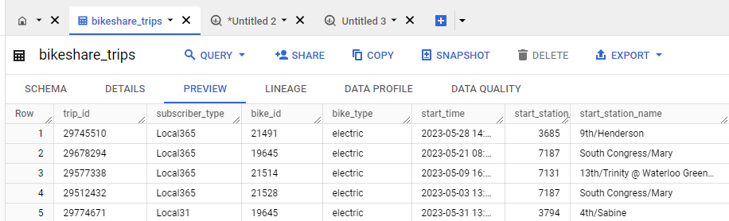

Note: Many of the public databases on BigQuery are living records and, as such, are periodically updated with new data. Throughout this course (and others in this certificate program), if your results differ from those you encounter in videos or screenshots, there's a good chance it is due to a data refresh.

### 

### Step 3: Create a temporary table

Now search the data to give the bikeshare company the information it needs for its blog post. Make sure it includes the name of the station where the bike is used most often.

You will need to create a temp table to find the ID number of the bike that has taken the longest total trips (in minutes). You will take a sum of the minutes of each trip for each bike, then sort by descending order to find the bike that was used for the most minutes. Follow these steps:

1. Return to your Editor tab or select Compose new query to open a query window.

2. Use **WITH** at the start of your query to set up a temp table and name your table longest_used_bike on a new indented line. Note: Always be sure to use the proper snake case (underscores between each word).

3. Add a space.

4. Enter **AS** and an open parenthesis [**(**]. Press Enter (Windows) or Return (Mac) to create a new indented line.

5. Enter **SELECT**, then press Enter/Return, then Tab to create a new indented line.

6. Enter **bike_id** followed by a comma and press Enter/Return to create a new line.

7. Enter **SUM(duration_minutes) AS trip_duration**. This creates a column in the temp table that contains the sum of the total minutes a bike has been used. Press Enter/Return.

8. Press Backspace to align the cursor with **SELECT**, then enter **FROM**. Press Enter/Return, then Tab to create a new indented line.

9. Enter **bigquery-public-data.austin_bikeshare.bikeshare_trips** to specify the dataset you’ll be using.

10. Press Enter/Return, then Backspace to align the cursor with **SELECT**. Your final query should be something like this:

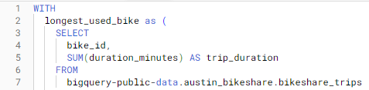

11. Enter **GROUP BY**, then press Enter/Return, followed by Tab to create a new indented line.

12. Enter **bike_id** to group the data by the bike_id column and press Enter/Return.

13. Press Backspace to align the cursor with **SELECT** and enter **ORDER BY**. Then press Enter/Return followed by Tab to create a new indented line.

14. Enter **trip_duration DESC** to sort the data in descending order by the column trip_duration.

15. Press Enter/Return, followed by Backspace to align the cursor with **SELECT**.

16. Enter **LIMIT 1** and Enter/Return.

17. Press Backspace, then add a closed parenthesis [)] if there isn’t one already on the next line. Now your text should be as follows:

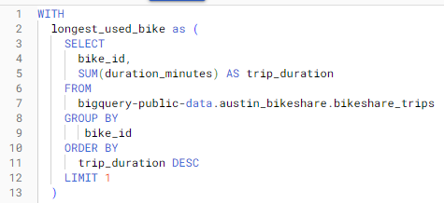

This is how you set up your temporary table to identify the specific bike (bike_id) with the longest trip duration. However, if you run it now, it will return an error because you haven’t written any queries for the temp table yet.

### 

### Step 4: Write your query

Now that you have a temp table that will show the bike ID of the bike that was used most often, you need to write a query to find the station. To do this, join your temp table with the original table and return the station ID with the highest number of trips started.

But first, create a comment describing the purpose of the query. This will help you remember it as you’re writing it, and it enables others to understand your work if you share it.

On a new line, enter two hashtags (**##**) to begin the comment and enter something like, **find station where the longest-used bike leaves most often.** Press Enter/Return to make a new line and follow these steps to write your query:

1. Enter **SELECT**, then Enter/Return followed by Tab to create a new indented line.

2. Enter **trips.start_station_id** followed by a comma. Then press Enter/Return to create a new line.

3. Enter **COUNT(*) AS trip_ct**. This will count the number of times the bike has left each station.

4. Press Enter/Return, followed by Backspace to align the cursor with **SELECT**.

5. Enter **FROM**, then press Enter/Return followed by Tab to create a new indented line.

6. Enter **longest_used_bike AS longest** to rename your temp table with an alias.

7. Press Enter/Return followed by Backspace to align the cursor with **SELECT**. At this point, your text should appear like this:

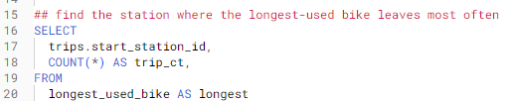

Next, write an **INNER JOIN** to pick out the station ID that corresponds to the bike you identified in the temporary table. Follow these steps

1. Enter **INNER JOIN**. Press Enter/Return, then Tab to create a new indented line.

2. Enter **bigquery-public-data.austin_bikeshare.bikeshare_trips AS trips**.

3. Press Enter/Return followed by Backspace to align the cursor with **SELECT**.

4. Enter **ON longest.bike_id = trips.bike_id**. This specifies that the **JOIN** is on the bike_id column in the temp table you created and in the original dataset. Press Enter/Return to create a new line.

5. Enter **GROUP BY**, then press Enter/Return followed by Tab to create a new indented line.

6. Enter **trips.start_station_id** to group by the start_station_id column in the original dataset.

7. Press Enter/Return followed by Backspace to align the cursor with **SELECT**.

8. Enter **ORDER BY**, then press Enter/Return followed by Tab to create a new indented line.

9. Enter **trip_ct DESC** to sort by the trip_ct column in descending order.

10. Press Enter/Return followed by Backspace to align the cursor with SELECT.

11. Enter **LIMIT 1**. At this point, your text should appear like this:

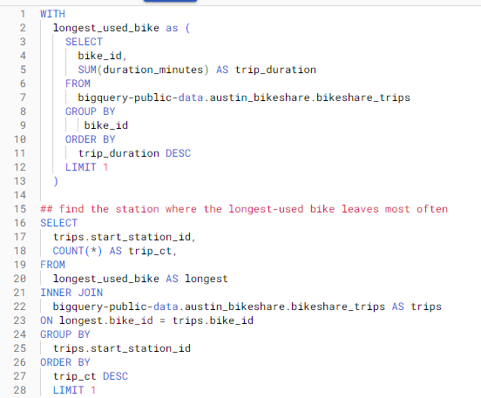

Now, select Run. The dataset is substantial, so the query might take a few seconds before showing you the count.

Note that this table is regularly updated on BigQuery, so the results can change depending on when you perform the query. However, your query should return a single row containing only a single start_station_id and a single trip_ct.

### 

### 

### Step 5: Review other types of temp tables

There are even more ways to create a temp table. Instead of using the **WITH** clause, you can use the **SELECT INTO** or the **CREATE TABLE** clauses.

The **SELECT INTO** clause copies data from one table into a new table, but doesn’t add the new table to the database. It’s useful if you want to make a copy of a table with a specific condition.

The **CREATE TABLE** clause is a good option when several people need to access the same temp table. This statement adds the table into the database.

## [MULTIPLE TABLE VARIATIONS](https://www.coursera.org/learn/analyze-data/lecture/C1bQ7/multiple-table-variations)

Earlier we introduced you to temporary tables. They're a great resource to use during your analysis because they help you keep your SQL code organized and efficient. You learned how to use a WITH clause to create a type of temporary table.

Now, we'll get into some other ways you can create temp tables along with the pros and cons they present. That's one of the great things about data analytics. **There's almost always more than one way to get your analysis done.**

The SELECT INTO statement is a good example of how to get a temp table done. This statement copies data from one table into a new table but it doesn't add the new table to the database. It's useful if you want to make a copy of a table with a specific condition, like a query with a WHERE clause. So far, we've been using BigQuery to show you how SQL works. But BigQuery doesn't currently recognize the SELECT INTO command.

Instead, here's an example of how a SELECT INTO statement might look in another RDBMS.

In the statement, a new table named Africa Sales is created using the data from the global sales database about the African region.

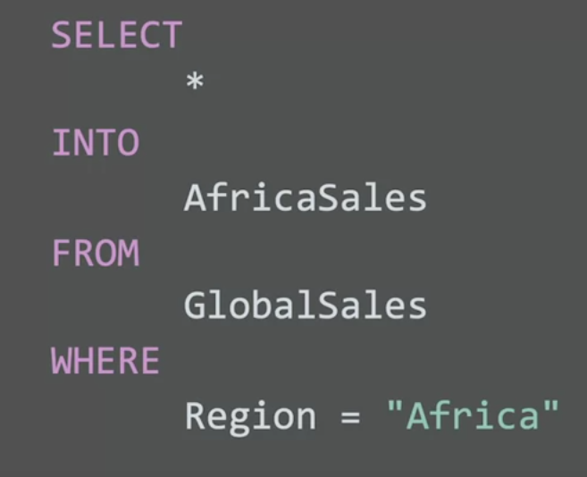

**Using SELECT INTO is a good practice when you want to keep the database uncluttered and you don't need other people using the table.**

Now, **if lots of people will be using the same table, then the CREATE TABLE statement might be the better option**. This statement does add the table into the database. If everyone needs access to the Africa Sales table, your query would start with CREATE TABLE, followed by the same SELECT-FROM-WHERE query as in the SELECT INTO statement.

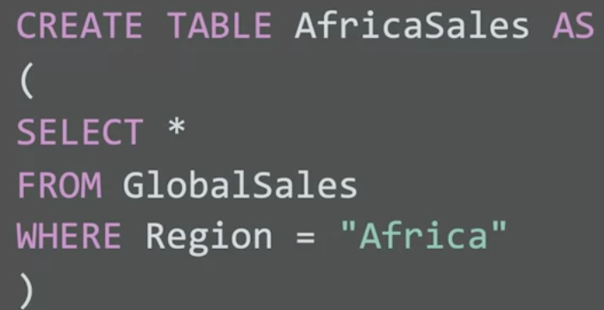

In most **relational database management systems or RDBMS**s, you can add metadata to describe the data that's contained in the table you've created. This can help make the table easier to understand for anyone using it. The CREATE TABLE statement is also useful for tables that are more complex. For example, if the code's difficult to replicate, then making a temp table in this way means it'll be safe for you to access later.

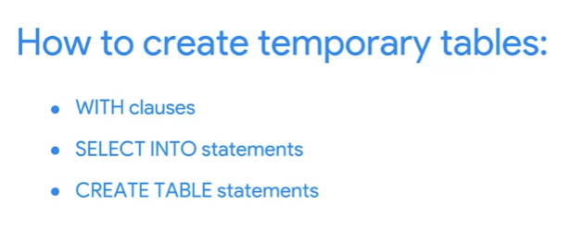

The way you create a temporary table using the WITH clause or a SELECT INTO or CREATE TABLE statement i**s usually up to you and your needs.**

The more you work in SQL, the more you might have preferences as well, especially since there's more than one way to create temporary tables. You may also find that you're working in an RDBMS that uses a different syntax. For example, you might need to use a CREATE TEMP TABLE statement instead of CREATE TABLE. Here's some good news. The syntax that you need for each unique RDBMS is usually pretty easy to find with a quick online search. But no matter how or where you create temporary tables, there isn't much downside to them. It's good to note though that sometimes building a temp table can interrupt your workflow. Again, that will depend on your objectives and your preferences. You can repeat your code over and over instead of making a temp table but that usually leaves your queries less readable and more vulnerable to typos. As you continue exploring the world of data analytics, you'll find that temporary tables are just one of the many resources you'll be able to use. The more you use them, the easier it'll be to navigate that world.

## [WORK WITH TEMPORARY TABLES](https://www.coursera.org/learn/analyze-data/supplement/oGADZ/work-with-temporary-tables)

**Temporary tables** are exactly what they sound like—temporary tables in a SQL database that aren’t stored permanently. In this reading, you will learn the methods to create temporary tables using SQL commands. You will also learn a few best practices to follow when working with temporary tables.

## 

## **A quick refresher on what you have already learned about temporary tables**

* They are automatically deleted from the database when you end your SQL session.
* They can be used as a holding area for storing values if you are making a series of calculations. This is sometimes referred to as **pre-processing** of the data.
* They can collect the results of multiple, separate queries. This is sometimes referred to as data **staging**. Staging is useful if you need to perform a query on the collected data or merge the collected data.
* They can store a filtered subset of the database. You don’t need to select and filter the data each time you work with it. In addition, using fewer SQL commands helps to keep your data clean.

It is important to point out that each database has its own unique set of commands to create and manage temporary tables. We have been working with BigQuery, so we will focus on the commands that work well in that environment. The rest of this reading will go over the ways to create temporary tables, primarily in BigQuery.

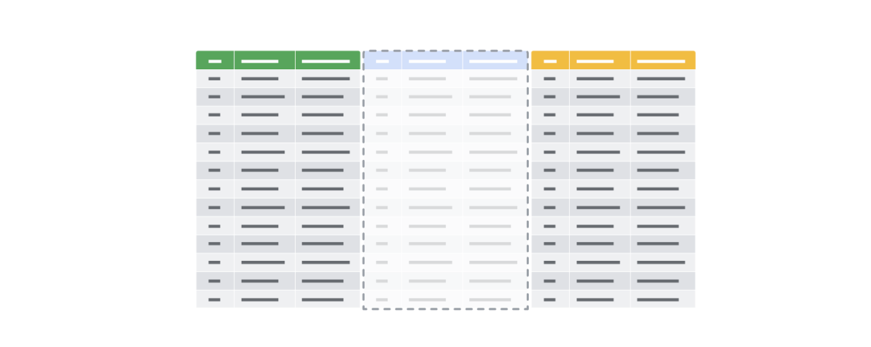

## **Temporary table creation in BigQuery**

Temporary tables can be created using different clauses. In BigQuery, the **WITH** clause can be used to create a temporary table. The general syntax for this method is as follows:

WITH

new_table_data AS (

SELECT *

FROM

Existing_table

WHERE

Tripduration >=60

)

Breaking down this query a bit, notice the following:

* The statement begins with the **WITH** clause followed by the name of the new temporary table you want to create
* The **AS** clause appears after the name of the new table. This clause instructs the database to put all of the data identified in the next part of the statement into the new table.
* The opening parenthesis after the **AS** clause creates the subquery that filters the data from an existing table. The subquery is a regular **SELECT** statement along with a **WHERE** clause to specify the data to be filtered.
* The closing parenthesis ends the subquery created by the **AS** clause.

When the database executes this query, it will first complete the subquery and assign the values that result from that subquery to **new_table_data**, which is the temporary table. You can then run multiple queries on this filtered data without having to filter the data every time.

## **Temporary table creation in other databases (not supported in BigQuery)**

The following method isn’t supported in BigQuery, but most other versions of SQL databases support it, including SQL Server and mySQL. Using **SELECT** and **INTO**, you can create a temporary table based on conditions defined by a **WHERE** clause to locate the information you need for the temporary table. The general syntax for this method is as follows:

SELECT

*

INTO

AfricaSales

FROM

GlobalSales

WHERE

Region = "Africa"

This **SELECT** statement uses the standard clauses like **FROM** and **WHERE**, but the **INTO** clause tells the database to store the data that is being requested in a new temporary table named, in this case, **AfricaSales**.

## **User-managed temporary table creation**

So far, we have explored ways of creating temporary tables that the database is responsible for managing. But, you can also create temporary tables that you can manage as a user. As an analyst, you might decide to create a temporary table for your analysis that you can manage yourself. You would use the **CREATE TABLE** statement to create this kind of temporary table. After you have finished working with the table, you would then delete or drop it from the database at the end of your session.

**Note:** BigQuery uses **CREATE TEMP TABLE** instead of **CREATE TABLE**, but the general syntax is the same.

CREATE TABLE table_name (

column1 datatype,

column2 datatype,

column3 datatype,

....

)

After you have completed working with your temporary table, you can remove the table from the database using the **DROP TABLE** clause. The general syntax is as follows:

DROP TABLE table_name

## **Best practices when working with temporary tables**

* **Global vs. local temporary tables:** Global temporary tables are made available to all database users and are deleted when all connections that use them have closed. Local temporary tables are made available only to the user whose query or connection established the temporary table. You will most likely be working with local temporary tables. If you have created a local temporary table and are the only person using it, you can drop the temporary table after you are done using it.
* **Dropping temporary tables after use:** Dropping a temporary table is a little different from deleting a temporary table. Dropping a temporary table not only removes the information contained in the rows of the table, but removes the table variable definitions (columns) themselves. Deleting a temporary table removes the rows of the table but leaves the table definition and columns ready to be used again. Although local temporary tables are dropped after you end your SQL session, it may not happen immediately. If a lot of processing is happening in the database, dropping your temporary tables after using them is a good practice to keep the database running smoothly.

## **For more information**

* [BigQuery Documentation for Temporary Tables](https://cloud.google.com/bigquery/docs/reference/standard-sql/data-definition-language#temporary_tables)**:** Documentation has the syntax to create temporary tables in BigQuery
* [How to use temporary tables via WITH in Google BigQuery](https://www.pascallandau.com/bigquery-snippets/use-temporary-tables-with-named-subquery/?utm_source=blog&utm_medium=rss&utm_campaign=development-feed)**:** Article describes how to use **WITH**
* [Introduction to Temporary Tables in SQL Server](https://codingsight.com/introduction-to-temporary-tables-in-sql-server/)**:** Article describes how to use **SELECT INTO** and **CREATE TABLE**
* [SQL Server Temporary Tables](https://www.sqlservertutorial.net/sql-server-basics/sql-server-temporary-tables/)**:** Article describes temporary table creation and removal
* [Choosing Between Table Variables and Temporary Tables](https://www.red-gate.com/hub/product-learning/sql-prompt/choosing-table-variables-temporary-tables)**:** Article describes the differences between passing variables in SQL statements vs. using temporary tables

## [YOUR INTERMEDIATE GUIDE TO SQL](https://www.coursera.org/learn/analyze-data/supplement/W4DUE/your-intermediate-guide-to-sql)

## [USE CONNECTED SHEETS WITH BIGQUERY](https://www.coursera.org/learn/analyze-data/supplement/U5ojF/use-connected-sheets-with-bigquery)

In this reading, you will learn about Connected Sheets, a tool that allows data professionals to use basic spreadsheet functions to analyze large datasets housed in BigQuery. With Connected Sheets users don’t need to know SQL. Instead, anyone, not just data professionals, can generate insights with basic spreadsheet operations such as formulas, charts, and pivot tables.

# 

# **What are Connected Sheets?**

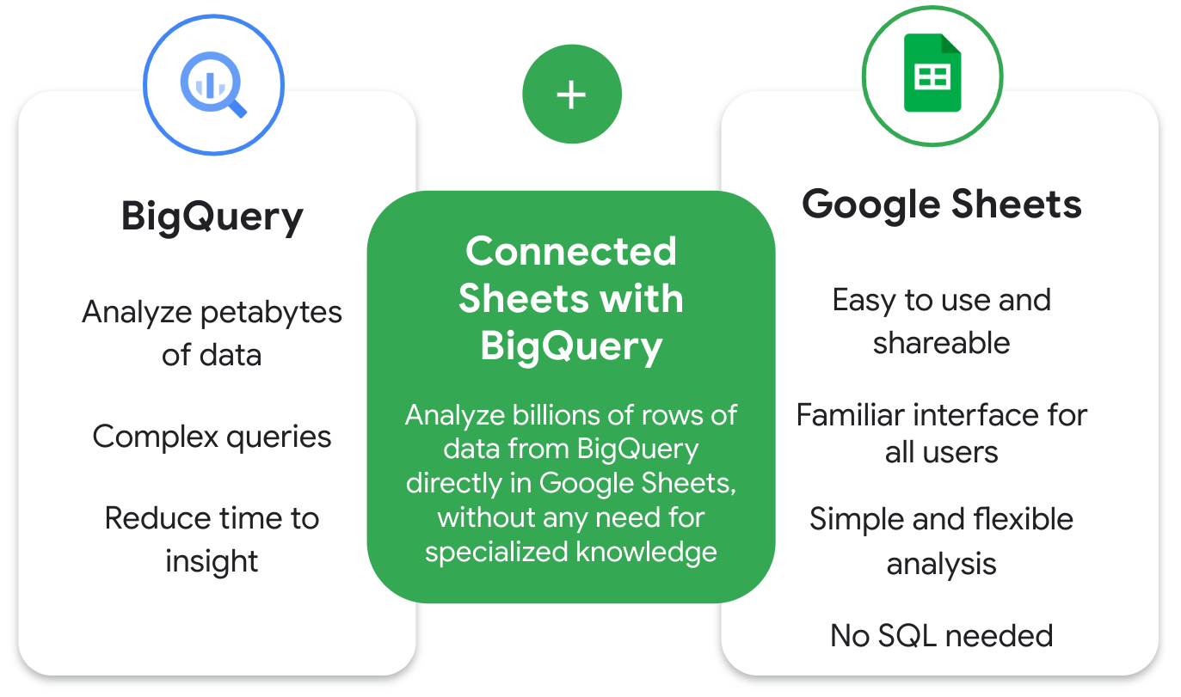

Recall that BigQuery allows users to analyze petabytes (a million gigabytes) of data using complex queries. A benefit of BigQuery is that it reduces the time needed to develop insights from large datasets.

Google Sheets, on the other hand, is a spreadsheet tool that is easy to use and shareable with a familiar interface. It also allows simple and flexible analysis with tools like pivot tables, charts, and formulas.

Connected Sheets integrates both BigQuery and Google Sheets, allowing the user to analyze billions of rows of data in Sheets without any need for specialized knowledge, such as SQL.

Additionally, Connected Sheets is built to handle big data. Users won’t experience the same limitations or performance issues they’ve had in the past (such as data loss) when working with large data sets in spreadsheets.

# **Why would a data analytics professional use Connected Sheets?**

As a data analytics professional, Connected Sheets can help with several tasks, such as:

* Collaborating with partners, analysts, or other stakeholders in a familiar spreadsheet interface;
* Ensuring a single source of truth for data analysis without additional .csv exports;
* Defining variables so that all users are working with the same data;
* Sharing insights with your team in a secure environment; and
* Streamlining your reporting and dashboard workflows.

Many teams and industries benefit from Connected Sheets such as finance, marketing, and operations teams.

A few example use cases of Connected Sheets include:

* **Business planning:** A user can build and prepare datasets, and then find insights from the data. For example, a data analyst can analyze sales data to determine which products sell better in different locations.
* **Customer service:** A user can find out which stores have the most complaints per 10,000 customers.
* **Sales:** A user can create internal finance and sales reports. After completing, they can share revenue reports with sales reps.
* **Logistics, fulfillment, and delivery:** A user can run real-time inventory management and intelligent analytics tools.

# **Connected Sheets benefits**

## **Collaborate with teammates and stakeholders**

Since Connects Sheets lives in Google Workspace, you can easily collaborate with other teammates and stakeholders in your company. If you’d like to limit access, you also control permissions for who can view, edit, or share the data.

## **Do more with familiar tools**

With Connected Sheets, you can access billions of rows of BigQuery data directly in Sheets. This direct access makes it easier for all employees to track, forecast, and analyze their data to get to better decisions faster.

## **Easily visualize data**

You can unlock insights from your BigQuery datasets using features you’re already familiar with in Sheets, such as pivot tables, charts, and formulas. These features help visualize large datasets more easily than using a more advanced language such as SQL. However, if you know SQL, you may prefer to use it in certain situations.

## **Up to date data**

With Connected Sheets, data professionals can ensure they are making decisions based on a single source of truth by setting up automatic refreshes of BigQuery data in Sheets.

## **Less data integrity and security risk**

While users can access big data with Connected Sheets, they won’t be able to accidentally manipulate or jeopardize the integrity of the data. There’s less security risk because data isn’t stored on individual workstations, it’s stored in the cloud.

**Connected Sheets shortcomings**

**Limited free pricing tier**

A shortcoming of Connected Sheets is that for the free pricing tier, users only receive 1 terabyte (TB) of processed query data each month. To process more data, you will need to move to a paid tier.

## **Data must be housed in BigQuery**

Another shortcoming is that you will need access to your data set in BigQuery. Without access to BigQuery, you won’t be able to analyze data in Connected Sheets.

## **Query will fail with large results**

A third shortcoming is that the Connected Sheets query will fail if the results are too large. Your query will fail if your pivot table has a significant amount of results, which could be anywhere from 30,000 to 50,000. To reduce your results, you can use filters or limit the number of rows per breakout

**Key takeaways**

Connected Sheets provides a tremendous opportunity to analyze large data sets without specialized skills like SQL. Use familiar spreadsheet skills such as pivot tables, charts, and formulas to analyze the data. For junior data analysts in particular, Connected Sheets can help them perform key tasks within BigQuery and increase their marketable skills.

## **Resources for more information**

* [Get started with BigQuery data in Google Sheets](https://support.google.com/docs/answer/9702507)
* [Insights at scale with Google Sheets](https://www.youtube.com/watch?v=jMKxhOJogEE)
* [Connected Sheets product announcement](https://workspace.google.com/blog/product-announcements/connected-sheets-is-generally-available)

## [TEST YOUR KNOWLEDGE ON USING SQL WITH TEMPORARY TABLES](https://www.coursera.org/learn/analyze-data/quiz/HXUhR/test-your-knowledge-on-using-sql-with-temporary-tables)

## MODULE 4 CHALLENGES

### [GLOSSARY TERMS FROM MODULE 4](https://www.coursera.org/learn/analyze-data/supplement/0raUI/glossary-terms-from-module-4)

Terms and definitions for Course 5, Module 4

**Array:** A collection of values in spreadsheet cells

**Calculated field:** A new field within a pivot table that carries out certain calculations based on the values of other fields

**Data security:** Protecting data from unauthorized access or corruption by adopting safety measures

**Data validation process:** The process of checking and rechecking the quality of data so that it is complete, accurate, secure and consistent

**GROUP BY:** A SQL clause that groups rows that have the same values from a table into summary rows

**Modulo:** An operator (%) that returns the remainder when one number is divided by another

**Profit margin:** A percentage that indicates how many cents of profit has been generated for each dollar of sale

**Summary table:** A table used to summarize statistical information about data

**SUMPRODUCT:** A function that multiplies arrays and returns the sum of those products

**Temporary table:** A database table that is created and exists temporarily on a database server

**Underscores**: Lines used to underline words and connect text characters

### 

## COURSE WRAP-UP

## [COURSE 5 GLOSSARY](https://www.coursera.org/learn/analyze-data/supplement/0p8b6/course-5-glossary)

## 